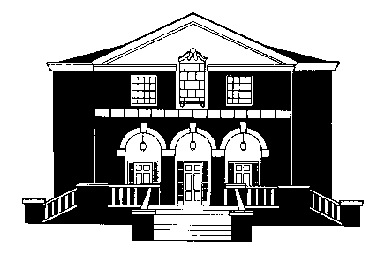
SCHOOL OF MUSIC AND DANCE
Beall Concert Hall Tuesday evening
6:00 p.m. January 25, 2011

DOCTORAL RECITAL

rAFael videira, viola

assisted by

Kylie Kershaw, harpsichord
Luke Larsen, piano
Nattapol Tantikarn, piano

This recital is presented in partial
fulfillment of the requirements for the
Doctor of Musical Arts
in Viola Performance

Rafael Videira is a student of Dr. Leslie Straka

* * *
PROGRAM
Sonata in G Major, BWV 1027 J.S. Bach
I. Adagio (1685-1750)
II. Allegro ma non tanto
III. Andante
IV. Allegro moderato

Kylie Kershaw, harpsichord

Chahagir, Op. 56a A. Hovhaness
(1911-2000)

INTERMISSION

Pensiero F. Bridge
(1879-1941)
Nattapol Tantikarn, piano

Sonata for the Arpeggione, D. 821 F. Schubert
I. Allegro moderato (1797-1828)
II. Adagio
III. Allegretto

Luke Larsen, piano

* * *

