Laser Safety

LASER SAFETY

The Human Eye
A schematic diagram of the eye is shown in Figure LS-1. The cornea is the clear film that covers the surface of the eye. The iris controls the amount of light entering the eye. The cornea and lens are the elements that focus the incoming light onto the retina, where light sensitive cells detect the light. Ultraviolet light tends to be absorbed by the cornea. Although corneal cells can regenerate (to an extent), UV radiation in sunlight can permanently damage the cornea if the eye is exposed to excessive bright sunlight over many years. This is one reason why it is a good idea to wear UV-blocking sunglasses during summer.
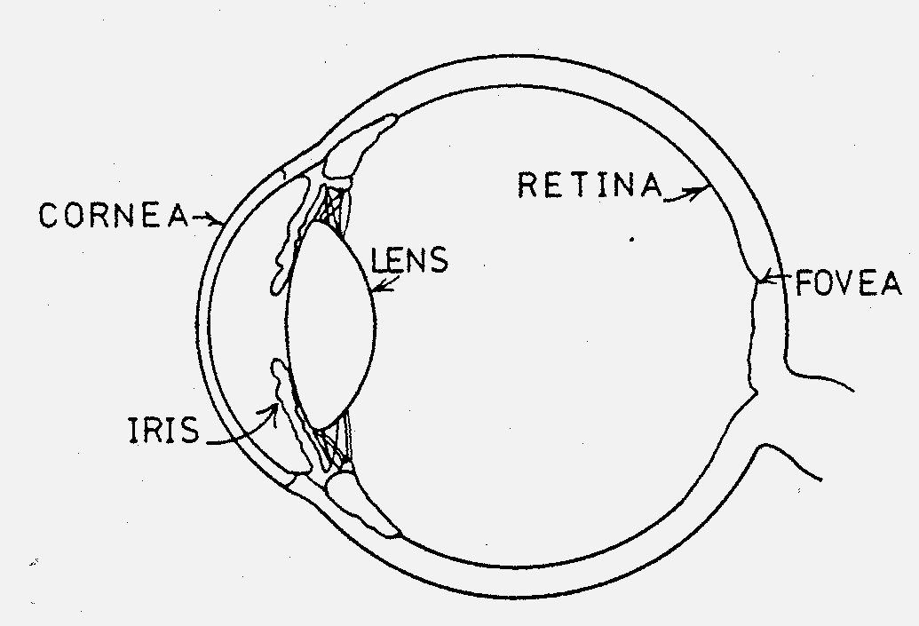
Visible and near infrared optical radiation is focused onto, and absorbed by the retina. Exposure to high intensity light from a source of optical radiation will cause instantaneous damage to the retina because the light source will be focused onto a small number of cells. The damage will be permanent, because retinal cells do not regenerate.

Figure LS-1: Schematic diagram of the eye
With a normal light source (like an incandescent light bulb), the optical energy spreads evenly in all directions. If you double the distance between your eye and the bulb, then the optical energy entering your eye falls by a factor of four. Thus, distance from the light source offers a level of protection.
The Danger of Laser Light
Looking directly into the beam of a low power (1 mW) visible laser can cause considerably more retinal damage than looking directly at the sun! With a laser, the optical energy is contained in a very narrow beam that does not spread out much. Even at relatively large distances, the laser beam spot can still be very small and, thus, the optical energy entering the eye can still be very high.
In addition, the almost parallel laser light irradiating the eye is focused to a very sharp point on the retina. This means that most of the energy emitted by the laser will be concentrated onto only a few cells on the retina causing maximum damage to those cells.
Minimizing the Danger
How can we minimise the exposure risk when dealing with a laser (even a laser pointer)? Try to always follow the following safety procedures:
- Terminate the beam at the end of its useful path (i.e., with a photodetector and/or a non-reflective beam stop behind the detector). A large piece of dark-colored cardboard mounted vertically in a slotted wooden base makes a good beam stop.
- Avoid specular reflection from polished or shiny surfaces (including watches and jewelery), as these will reflect the laser beam around the lab or classroom in an uncontrolled manner.
- Use the lowest practical intensity when you align the laser beam. Use partially crossed linear polarisers to temporarily reduce (attenuate) the beam intensity. (The two polarized plastic lenses of cheap Polaroid sunglasses can be used.)
- Never look directly into the laser beam. Construct your laser beam path as low as practical to the table or bench top, and then always try to keep your head well above the level of the laser beam. When aligning, move your eye slowly when near the beam path. The bright halo associated with the beam gives an early warning of impending disaster (as your eye approaches a direct line of vision with the beam).
- Avoid darkened rooms. Do not set up your laser beam in a darkened room, as your pupils will enlarge and therefore potentially will let more of the laser beam energy onto the retina.
- Always use laser warning signs to alert others to the potential laser radiation hazard. You should print copies of laser warning signs like those shown below, and display them prominently close to any laser experiment.
