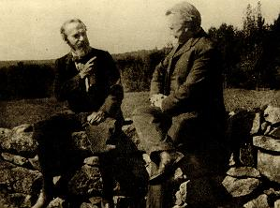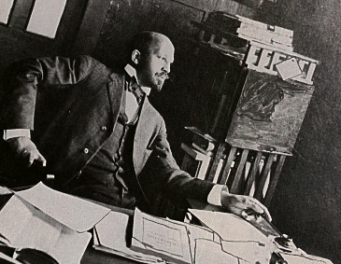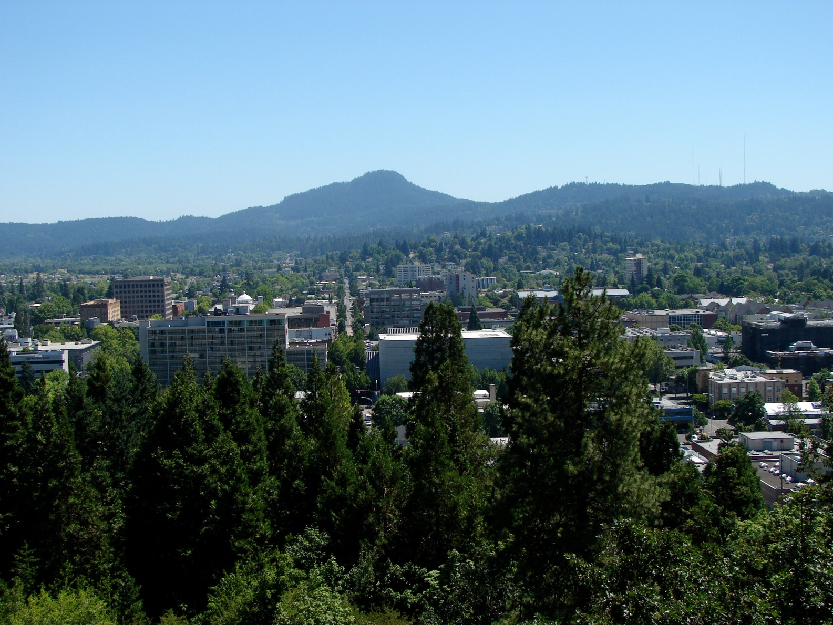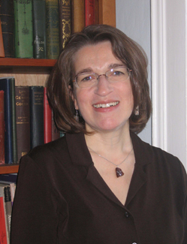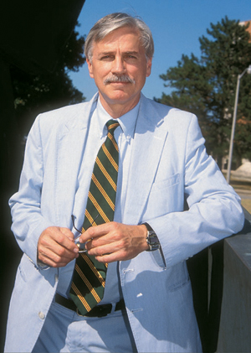

The aim of this seminar is to explore the political philosophical resources of a wider range of pragmatist voices in a way that is both of and beyond Deweyan political theory.  Seminar leaders will present on a range of figures (tentatively) including: William James, Josiah Royce, Charles Sanders Peirce, and Richard Rorty. Seminar Leaders: Colin Koopman (Oregon) and Jackie Kegley (UC Bakersfield).

# Seminars

For registration and additional program information please go the Society for the Advancement of American Philosophy at http://www.american-philosophy.org/or the Oregon Philosophy Department at<http://philosophy.uoregon.edu/>.

🙞🙜

#### Latin American Philosophy

The presenters in this session will highlight the diversity of approaches, issues, and styles that characterize the quickly growing field of Latin American philosophy. In so doing they will describe the manner in which Latin American thought stands to extend, and in many cases revise, the standard conception of classical American philosophy that has hitherto excluded thinkers that did fit easily within an Anglo-European context.

Seminar Leaders: David O’Hara (Augustana) and Joseph Orosco (Oregon State)

Three scholars discuss the various modes of philosophical praxis that they take to either be American or to mark out, prescriptively, how one should philosophize in the American context. Seminar Leader: John Lysaker (Emory)

#### How to be an American Philosopher

In this seminar we will consider two of DuBois’s most influential works, *Darkwater* (1920) and *Souls of Black Folk* (1903). Our intention in rereading these works is to situate them in the wider context of American philosophy and social-political philosophy more generally. Additionally, by addressing these complimentary works that focus on the “veil” of racial discrimination and objectification, we have the chance to witness an important shift in DuBois’s own thinking on these topics. Seminar Leader: Denise James (University of Dayton)

#### Rereading W. E. B.

#### Du Bois

### Sponsored by the Society for the Advancement of American Philosophy and the Department of Philosophy, University of Oregon

#### Expanding the Voices of Pragmatist Political Philosophy

# Seminars

🙞🙜

July 26-31, 2010

University of Oregon

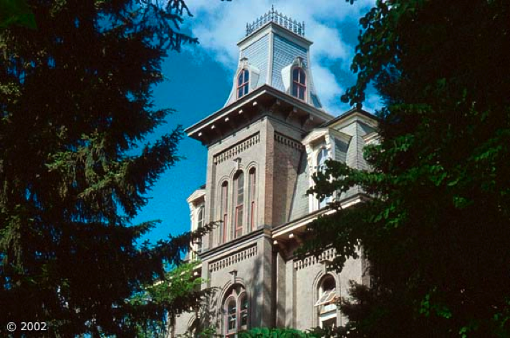

Summer Institute in American Philosophy

The **Summer Institute in American Philosophy** is designed for faculty members and advanced graduate and postdoctoral students in philosophy and related disciplines interested in research and study in the American philosophic tradition. The program consists of four seminars focused on central figures and problem areas in the tradition. This year’s theme will be “American Diversity and Democratic Dissent.”

Reading assignments for the seminars will be posted online in early April. Seminars will involve lecture and discussion. Housing is available on campus in one of the UO residence halls and nearby at one of local inns or hotels. The program include some time away from sessions to join a wine-tasting excursion, visit the Oregon coast or hike in one of the nearby national forests in the Cascade mountains.

**Call for Abstracts: Works in Progress**

This year’s program will include several one-hour "Works-in-Progress" sessions, at which interested persons may present their current research projects, especially books, and receive critical feedback from Institute attendees.

There will also be a dissertation workshop at which graduate students, at any stage in the process of writing their dissertations, will present brief summaries of their work and receive feedback from Institute attendees.

Those wishing to present their work should submit, by May 1, a 150-to-300-word abstract to John Kaag at [John_Kaag@uml.edu](mailto:John_Kaag@uml.edu). Submitted abstracts will be blind reviewed and authors of accepted abstracts will be added to the Institute program. Authors of projects received by May 1 will also be added to the final Institute program.

Dorothy Rogers (Associate Professor of Philosophy) earned her Ph.D. as well as a master's in theological studies from Boston University. She is the author of America’s First Women Philosophers: Transplanting Hegel, and has served as editor of collections of the works of neglected women philosophers, including Catharine Beecher, the women of the St. Louis Philosophical Movement, and women in the American academy (1880-1900).

Larry A. Hickman is the Director of the Center for Dewey Studies and Professor of Philosophy at Southern Illinois University Carbondale. This website contains information about his research, teaching, and professional activities. It also contains photos and other information that pertain to his work at the Center for Dewey Studies.

## Keynote Speakers