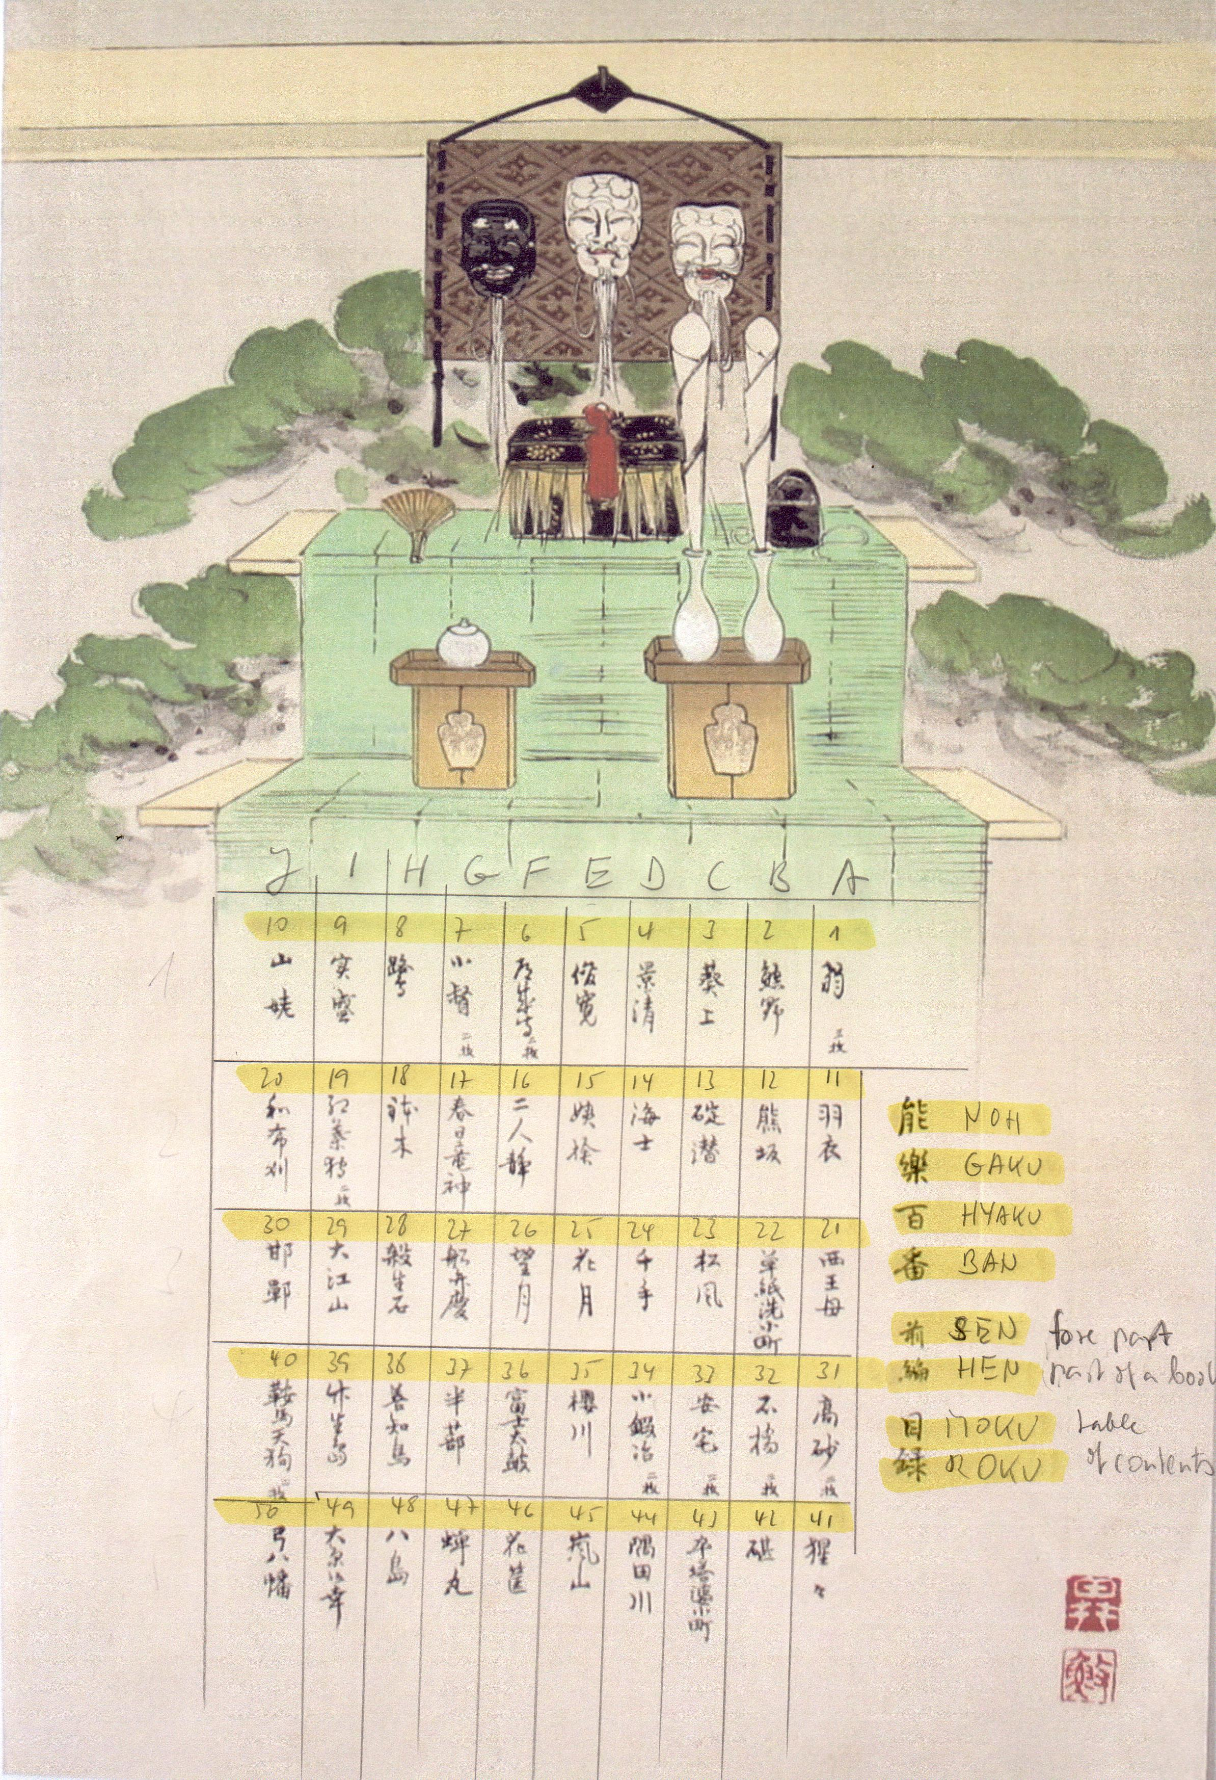 | 能 Noh  楽 Gaku  百 Hyaku  番 Ban  前 Zen fore part  編 Hen part of a book (volume)  目 Moku  録 roku table of contents

Column |  | Top down (the order in the album is #1, #11, #21, #31, #41, #2, #12, #22, #32, #42, #3, #13, etc.)
A | #1 |  | #11 | #21 | #31 | #41
 | Okina  a set of 3 pictures |  | Hagoromo | Saiobo | Takasago  a set of 2 pictures | Shojo
B | #2 |  | #12 | #22 | #32 | #42
 | Yuya |  | Kumasaka | Soshi arai Komachi | Shakkyo  a set of 2 pictures | Kinuta
C | #3 |  | #13 | #23 | #33 | #43
 | Aoi no ue |  | Ikarikazuki | Matsukaze | Ataka  a set of 2 pictures | Sotoba Komachi
D | #4 |  | #14 | #24 | #34 | #44
 | Kagekiyo |  | Ama | Senju | Kokaji  a set of 2 pictures | Sumidagawa
E | #5 |  | #15 | #25 | #35 | #45
 | Shunkan |  | Ubasute | Kagetsu | Sakuragawa | Arashiyama
F | #6 |  | #16 | #26 | #36 | #46
 | Dojoji  a set of 2 pictures (shite before, shite later) |  | Ninin (Futari) shizuka | Mochizuki | Fuji daiko | Hanagatami
G | #7 |  | #17 | #27 | #37 | #47
 | Kogo  a set of 2 pictures |  | Kasuga ryujin | Funa Benkei | Hajitomi | Semimaru
H | #8 |  | #18 | #28 | #38 | #48
 | Sagi |  | Hachi no ki | Sesshoseki | Uto | Yashima
I | #9 |  | #19 | #29 | #39 | #49
 | Sanemori |  | Momiji gari  a set of 2 pictures | Oe-yama | Chikubushima | Oharagoko
J | #10 |  | #20 | #30 | #40 | #50
 | Yamauba |  | Mekari | Kantan | Kuruma tengu | Yumi yawata

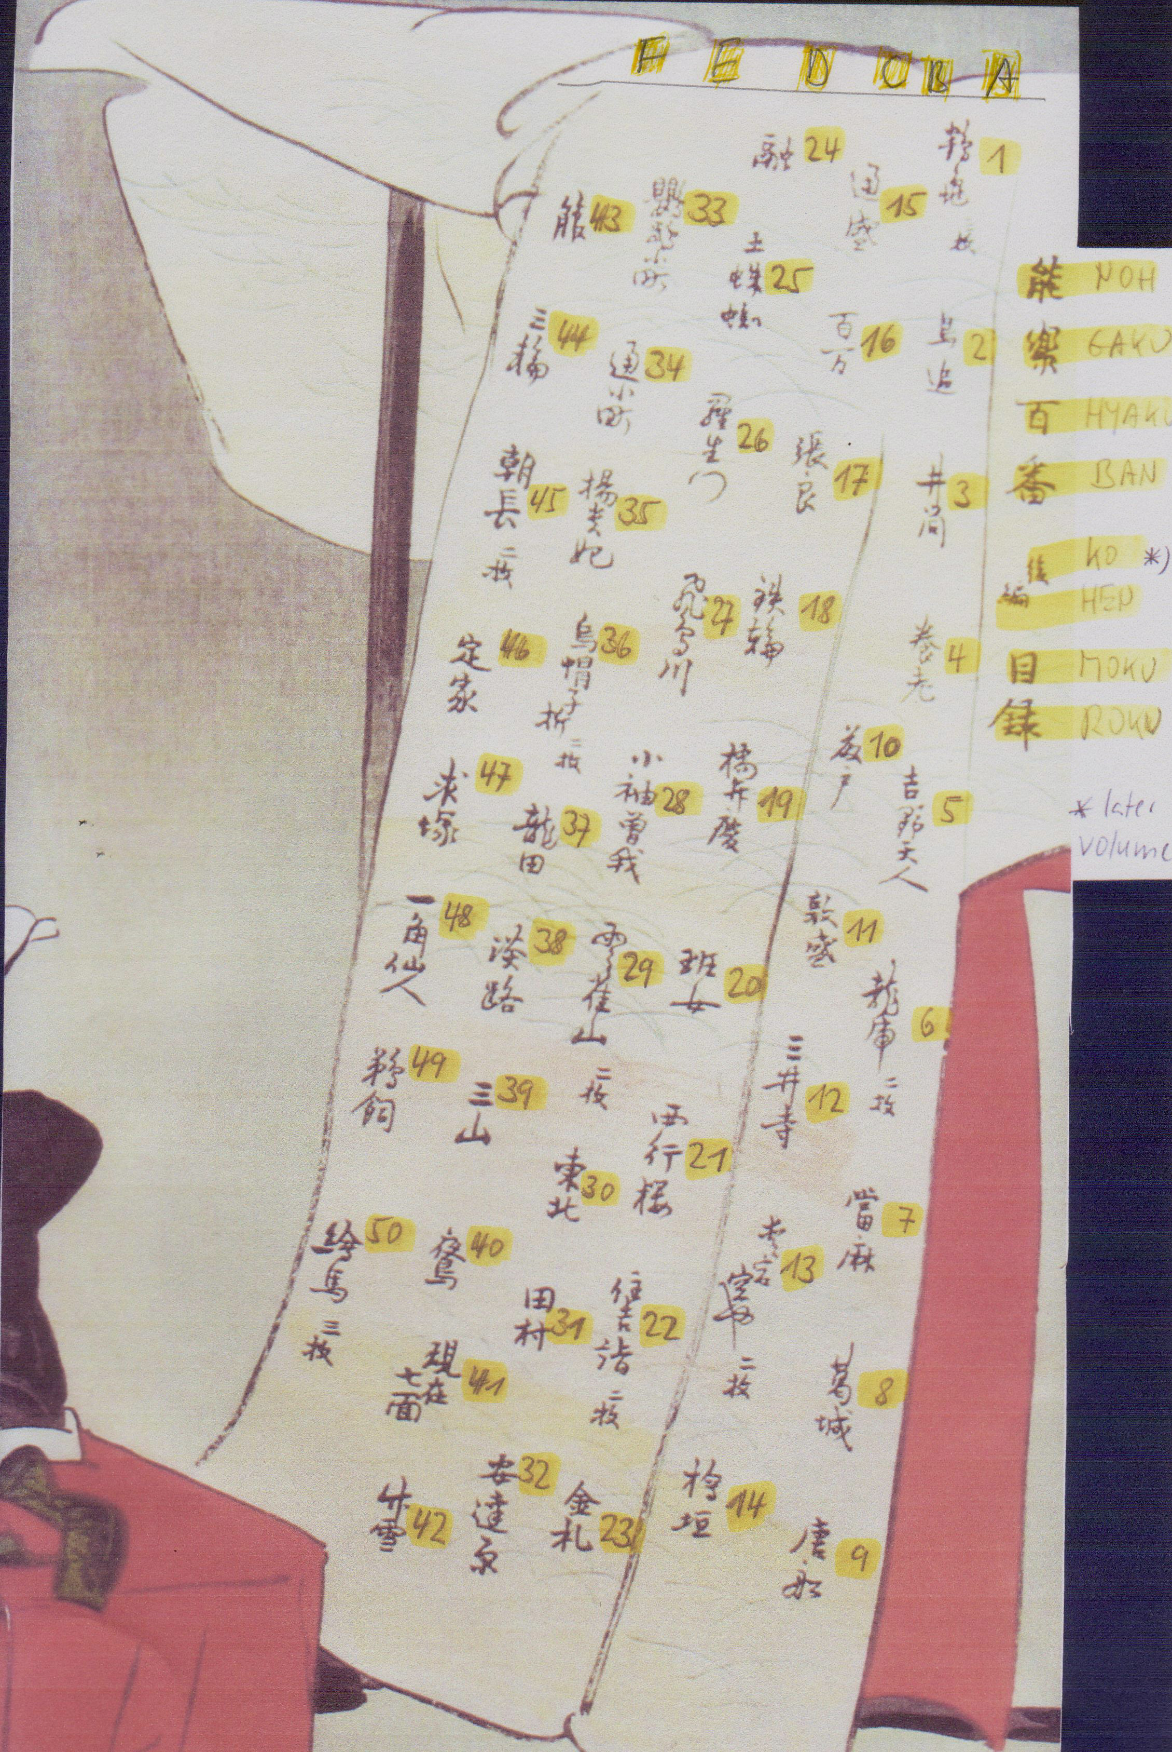 | 能 Noh  楽 Gaku  百 Hyaku  番 Ban  後 Ko  編 hen later volume  目 Moku  録 roku table of contents

Column |  | Top down (the order in the album is #1, #2, #3, #4, #5, #6, #7, #8, #9, #10, #11, etc.)
A | #1 |  | #2 | #3 | #4 | #5 | #6 | #7 | #8 | #9
 | Tsurukame  a set of 3 pictures |  | Tori-oi-(bune) | Izutsu | Yoro | Yoshino tennin | Ryuko  a set of 2 pictures | Taima | Katsuragi | Tosen
B | #10 |  | #11 | #12 | #13 | #14
 | Fuzito |  | Atsumori | Miidera | Atagokuya  a set of 2 pictures | Higaki
C | #15 |  | #16 | #17 | #18 | #19 | #20 | #21 | #22 | #23
 | Michimori |  | Hyakuman | Choryo | Kanawa | Hashi Benkei | Hanjo | Saigyo zakura | Sumiyoshi mode  a set of 2 pictures | Kinsatsu
D | #24 |  | #25 | #26 | #27 | #28 | #29 | #30 | #31 | #32
 | Toru |  | Tsuchi  gumo | Rashomon | Asuka  gawa | Kosode Soga | Hibari  yama  a set of 2 pictures | Tohoku | Tamura | Adachi  gahara
E | #33 |  | #34 | #35 | #36 | #37 | #38 | #39 | #40 | #41 | #42
 | Omu Komachi |  | Kayoi Komachi | Yokihi | Eboshi ori  a set of 2 pictures | Tatsuta | Awaji | Mitsu  yama | Nue | Genzai shichimen | Take no yuki
F | #43 |  | #44 | #45 | #46 | #47 | #48 | #49 | #50
 | Ebira |  | Miwa | Tomonaga  a set of 2 pictures | Teika | Motome-zuka | Ikkaku-sennin | Ukai | Ema  a set of 3 pictures

