Interactive Lecture Demonstrations
Prediction Sheet--Newton's 1st & 2nd Laws

Directions: This sheet will may be collected by your instructor. Write your name at the top to record your presence and participation in these demonstrations. Follow the directions. Always make your predictions before making observations.

Demonstration 1: The positive direction is to the right. The frictional force acting on a small toy cart is very small (almost no friction) and can be ignored. The cart is pulled with a constant force (the applied force) so to the right and speeds up at a steady rate (constant acceleration). On the axes on the right sketch your predictions of the velocity and acceleration of the cart and the applied and net force on the cart after it is released and during the time the cart is moving under the influence of the constant force. (Applied and net force are the same in this case. Why?)  Only after you have made your predictions, observe the motion of the cart and the resulting graphs by clicking FvaVideo1. After you view the video, you can click on FVAGraph1 to have the graphs persistently displayed on the screen.  Compare the graphs to your predictions and explain any differences.  Demonstration 2: The frictional force acting on the cart is now increased. The cart is pulled with the same constant force (the applied force) as in Demonstration 1 so that it moves to the right speeding up at a steady rate (constant acceleration). On the same axes to the right sketch your predictions of the velocity and acceleration of the cart and the applied and net force on the cart after it is released. (Note that the applied and net force are different now. Which one determines the acceleration?) We are measuring only the applied force.  Only after you have made your predictions, observe the motion of the cart and the resulting graphs by clicking FvaVideo2. After you view the video, you can click on FVAGraph2 to have the graphs persistently displayed on the screen.  Compare the graphs to your predictions and explain any differences.  Summarize your observations:  (1) Newton's Second Law says that the acceleration of an object is determined by which: the applied force or the net force? Explain based on your observations.  (2) If an object is acted on by an applied force and friction, how do you calculate the net force? | 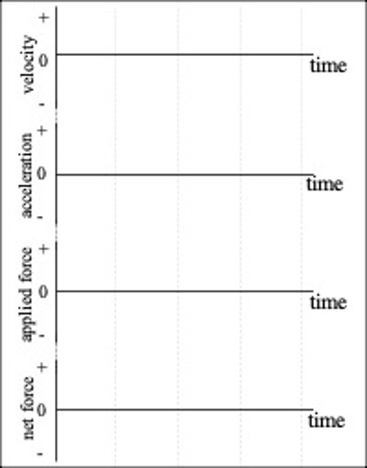

Demonstration 3: The positive direction is to the right. A toy cart has equal and opposite forces acting on it (due to two fans blowing in opposite directions). The frictional force is very small (almost no friction) and can be ignored. The cart is given a quick push to the right and released. Sketch on the right your predictions of the velocity and acceleration of the cart after it is released. What is the net (or resultant) force on the cart after it is released?  Only after making your predictions, click DuelingFans to download and view the movie. Compare your observations to your predictions and explain any differences. Can an object with no net force acting on it move?  How is this related to Newton's First Law? | 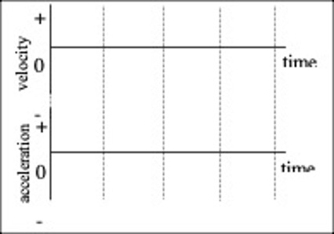

Demonstration 4: The positive direction is to the right. A crate is on the surface of a frozen lake so that friction is very small. The crate is given a brief push to the right and then released. Sketch on the axes on the right your predictions of the velocity and applied force for the motion, including the time during the push. Is the net force the same as the applied force in this case?  Only after you have made your prediction, open the simulation Forces and Motion:  https://phet.colorado.edu/sims/cheerpj/motion-series/latest/motion-series.html?simulation=forces-and-motion  To set up to graph Force and Velocity click on FORCE GRAPHS and then Velocity+. Click on the X to get rid of the barriers. On right check Ice (no friction) and Choose Small Crate as the object. Use the slider to set the Position as far to the left as possible. Set the force to +200 N by typing 200 in the box and then click. As the crate starts moving to the right, immediately type 0 in the F_{Applied} box, and after 3 sec hit Return to change the applied force to zero. When the crate reaches the right side click  to stop graphing.  Compare the resulting graphs to your predictions and explain any differences.  After the force is no longer applied (reduced to zero) does the crate still move? Why?  How is this related to Newton's First Law? | 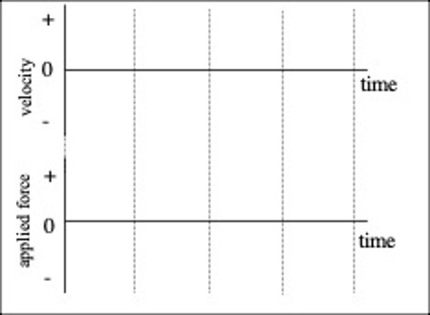
Demonstration 5: The positive direction is to the right. The frictional force acting on the crate remains very small (almost no friction) and can be ignored. The crate is given a push toward the right and released After it is released, a constant force pushes on it to the left. It moves to the right, slowing down at a steady rate (constant acceleration), comes to rest momentarily and then moves to the left, speeding up at a steady rate. Sketch on the axes on the right your predictions of the velocity and acceleration and of the force on the crate after the crate is released.  Only after you have made your predictions, use the same simulation, Forces and Motion, to test them.  First click Reset All and Yes. To set up to graph Force, Velocity and Acceleration click on FORCE GRAPHS and then Acceleration+ and Velocity+. Get rid of the barriers, check Ice (no friction), Choose Small Crate and set the Position as far to the left as possible. Set the force to +500 N and then click. Immediately type -500 in the F_{Applied} box, and after 2 sec hit Return to change the applied force to 500 N toward the left. When the crate reaches the left side again, click to stop graphing.  Compare the resulting graphs to your predictions and explain any differences.  Why is the net force on the crate essentially the same as the applied force in this case?  How does the acceleration at the point the crate reverses direction compare to the acceleration before it reverses direction? After? Explain.  How does the force at the point the crate reverses direction compare to the force before it reverses direction? After? | 