Physics education with multimedia applications in non-English teacher-oriented journals: an analysis of 491 articles about multimedia in physics education
Abstract. Journals, intended for teachers, provide practical ideas about the use of multimedia in physics teaching and learning. However, the articles in such journals are usually written in local languages. Here, ten researchers in physics education from different countries provide a review of articles on multimedia applications and corresponding concepts that are discussed in country-specific languages (excluding English). A total of 491 articles about multimedia applications were analysed, using a list of 81 categories. Central topics included teaching strategies, technologies and multimedia features. Furthermore, differences between countries, changes over time, and notable patterns of articles in 34 teacher-oriented journals from 10 countries are presented.
Current literature offers a broad range of ideas related to the practical use of multimedia. Topics of focus differ between countries and languages, suggesting more international exchange to circulate the best ideas of concrete teaching material for schools across Europe. Furthermore, our findings also suggest a need for improvement in the dissemination of current research findings, as well as a solid theoretical grounding among those who write articles for teacher-oriented journals in local languages.
This article collects and summarizes findings that may be relevant for the international group of scientists and for possible future collaborations.
- Introduction
We are particularly grateful to Henk Pol (University of Twente, Enschede), Víctor López (Autonomous University of Barcelona, Barcelona, Spain), Marisa Michelini & Alberto Stefanel (University of Udine, Udine, Italy), Tomasz Greczyło (University of Wroclaw, Wroclaw, Poland), Andreas Müller (Université de Genève, Genève, Switzerland), Bor Gregorcic (Uppsala Universitet, Uppsala, Sweden ) & Mihály Hömöstrei (Eötvös Loránd University, Budapest, Hungary) who reviewed the Dutch, Spanish/Catalan, Italian, Polish, French, Swedish, Hungarian articles and provided all the available data described in [1].
Journals for teachers offer a large pool of practical ideas for using multimedia in teaching and learning physics. However, as teachers usually use local languages for instruction, articles are written in local languages. Twenty-four official languages in the EU generate a considerable barrier for an exchange of teaching and learning material. Thus, experiences and recommendations for teaching and learning in one country often are not adopted in neighboured countries.
For this reason, ten scientific members from the group MPTL (Multimedia in Physics Teaching and Learning) from eight countries produced a review about articles on multimedia applications in country-specific languages (excluding English) [1]. In the process, the corresponding concepts were analysed and discussed. A precisely written report about findings is published in [1]. In the present paper, additional analysis is presented, focussing on existing challenges that might be improved by a community of experts.
One of the most well documented activities in the meta-analysis of 74 studies by Kyndt, Gijbels, Grosemans, and Donche (2016) was consulting information resources, including reading professional literature [2], which asserts that teacher-oriented journals play an important role in teachers’ informal learning
Effective development programs for teachers have to offer specific, concrete and practical ideas that directly relate to the day-to-day activities in classrooms [3]. A recent report about teacher training also emphasizes this aspect [4]. Nevertheless, Fraser [5] as well as Kwakman [6] state that deeper insights of teachers’ informal learning activities are generally missing.
Articles about multimedia learning in international research journals rarely refer to national issues like curricula, local initiatives (like online labs), correlations between subject contents and further educational and technological aspects, or teaching traditions. Teacher-oriented journals have the potential to bridge the gap between theoretical considerations in scientific journals and practical use in teaching and learning situations, and they are a wellspring of examples of what is thought by practitioners to be effective for teaching. Thus, an analysis of articles in teacher-oriented journals can provide insight into what combinations of content, material and teaching strategies are currently discussed in physics education research, which, in turn, can provide suggestions for practical teaching.
Furthermore, teacher-oriented journals can directly address topics that Scherer, Tondeur, and Siddiq [7] used for their specification of TPACK. Specifically, intersections between pedagogical knowledge and technological knowledge, content knowledge and technological knowledge, as well as the combination of all – TPACK (see figure 1) can be addressed and made more concrete with applicable examples for teaching in schools.

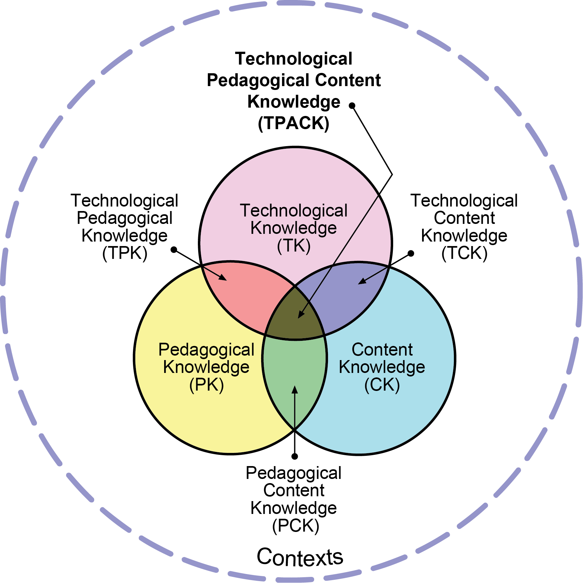
Figure 1. The TPACK framework (from http://tpack.org). TPK, TCK, and TPACK as intersections of pedagogical knowledge, content knowledge and technological knowledge.
The review[1] addressed the following research questions:
- What are the most commonly addressed topics in teacher-oriented journals?
- Are certain combinations of content and multimedia applications preferred?
- Which types of multimedia applications are favoured for different learning phases?
- Who is intended to be actively using multimedia tools (teacher, student or learning groups)?
- Is it possible to classify the articles according to special facets/patterns?
- Are different types of articles preferred in different languages?
- Are there changes over time –e.g. between the first and the second half of the period of study?
- How often are suggested approaches based on theoretical/empirical findings?

A selection of findings with a special focus on open questions and needs for cooperative working is described here. For further aspects and findings see [1].

- Methods
491 articles from 34 teacher-oriented journals from 10 countries about multimedia applications were analysed, using a list of 11 dimensions, subdivided into 81 categories. Dimensions consisted of:
- Type of article (Overview, general concepts for teaching and learning, …)
- Content (eg. mechanics; acoustics, …)
- Addressess (primary; secondary I; secondary II; not specified)
- Who will be active (teacher; student (alone); learning groups; not specified)?
- Learning phase (eg. introduction to a topic; exploration, …)
- Teaching context (eg. strictly associated with a school curriculum; for general, flexible use; …)
- Scope (supplementary material for a lesson; material for one or two lesson; …)
- Availibility/costs
- Platform
- Special software used
- Internet (eg. no internet needed for running the application; internet-based program; …)
- Incorporation of Multimedia tools… (eg. experimental activities; data processing; …)
- Use of multimedia
- Multimedia characteristics addressed

In order to build this list, and inductive process was followed. First a list of criteria for categorization was collected from the literature on multimedia in physics teaching and learning, e.g. [8], [9], [7] and from standard literature on teacher education. Subsequently, based on selected articles and a discussion in our consortium the final list of 81 categories was defined. The full census of 491 articles concerning multimedia in physics education published in the journals under consideration from 2006-2015 were then characterised according to content, based on this list.
In addition to several descriptive statistics such as frequency analysis, a log-linear multiway frequency analysis of category assignments in paired dimensions and a cluster analysis of category assignments were carried out. This also provides insights about preferred combinations of content and patterns within articles in 34 teacher-oriented journals from 10 countries. Furthermore, differences between countries, changes over time, and trends in preferred teaching strategies were uncovered using simple spreadsheet statistics. More details are presented in [1].

- Results
  - Branches of physics
Content areas treated by the census articles differed according to languages. Table 1 shows the highest ranked topics (mechanics, electricity and magnetism, optics and astrophysics/relativity) and the languages in which the most articles are written. Also, the percentage of articles in a language treating a specified topic is noted. Thus, table 1 shows what topics were handled frequently, and in which language the most (or fewest) articles were addressing a particular topic. For example, in German and Spanish there are significant numbers of papers about mechanics; Electricity/magnetism assumes greater prominence in Italian articles but covers only 7 % of the German articles. This overview is presented to indicate topics for which an exchange of ideas could be fruitful, and countries that might especially benefit from intellectual exchange in these areas.

Table 1. Subject contents often (in more than 10% of articles) treated by language (only extraordinary high/low values presented).
 |  | Dutch | French | German | Italian | Polish | Spanish | All
Mechanics | Quantity |  |  | 54 | 10 | 5 | 40 | 140
 | % |  |  | 42,5% | 14,7% | 10,9% | 40,8% | 28,5%
Multiple Areas | Quantity | 47 |  |  |  |  |  | 137
 | % | 41,2% |  |  |  |  |  | 27,9%
Electricity, Magnetism, Electronics | Quantity |  |  | 9 | 19 |  |  | 51
 | % |  |  | 7,1% | 27,9% |  |  | 10,4%

Table 2 shows branches of physics that were treated seldom overall. Here, for example, it might be of interest to discuss and cooperate with colleagues from Spain to gather ideas about multimedia in thermodynamics. The same applies to fellows from Italy in the areas of quantum mechanics or solid-state physics.

Table 2. Rarely appearing branches (less than 5% of articles overall) of physics by language (only extraordinary high values are presented).
 |  | Dutch |  | French |  | German |  | Italian |  | Polish |  | Spanish |  | All
Quantum  Mechanics | Quantity |  |  |  |  |  |  |  | 9 |  |  |  |  | 24
 | % |  |  |  |  |  |  |  | 13,2% |  |  |  |  | 4,9%
Thermo-dynamics | Quantity |  |  |  |  |  |  |  | 6 |  |  |  | 9 | 23
 | % |  |  |  |  |  |  |  | 8,8% |  |  |  | 9,2% | 4,7%
Solid-State Physics | Quantity |  |  |  |  |  |  |  | 9 |  |  |  |  | 13
 | % |  |  |  |  |  |  |  | 13,2% |  |  |  |  | 2,6%
Nuclear and Particle Physics | Quantity |  |  |  |  |  |  |  |  |  |  |  |  | 7
 | % |  |  |  |  |  |  |  |  |  |  |  |  | 1,4%
Atoms and Molecules | Quantity |  |  |  |  |  |  |  |  |  |  |  |  | 6
 | % |  |  |  |  |  |  |  |  |  |  |  |  | 1,2%

  - Multimedia for certain subject contents
Multimedia can be applied to facilitate experimental procedures, to process data more easily, to represent knowledge in different manners (e.g. pictures, graphs, formulas, text), and to design tests and special tasks. It can also be used to to realize simulations or modelling, to visualize facts and issues in physics and show processes in animations, or to calculate numbers. Log-linear multiway frequency analysis (see ref [1]) can help to identify topics that were favoured by the multimedia tools above. Table 3 provides effect parameters for interaction effects (see ref [1]), and indicates by positive (larger) numbers, where a given multimedia tool was applied more often, and where multimedia use is comparatively rare (negative numbers).
Table 3. Multimedia suitable for certain subject contents (only striking numbers are presented, for the full model see [1]).
 | Experiment | Data Processing | Knowledge Representation | Testing, Feedback | Modelling, Simulation | Visualize,  Animation | Calculate
Mechanics | 0,69 *** |  | -1,22 ** |  | 0,32
Acoustics | 1,57 ***
Electricity, Magn., El. |  |  | 1,64 *** |  |  |  | 1,53 *
Quantum  Mech. | -1,49 * |  |  |  | 1,22 **
Astro  & Rel. | -1,48 ** |  |  |  |  | 1,75***
*** p < .001, ** p < .01, * p < .05.

Experimental activities that were well represented included mechanics and acoustics. Conversely, for quantum mechanics and astronomy, nearly no computer-assisted experimental activities are described.
Various representations are applied above for the topics of electricity and magnetism and quantum mechanics, in contrast with classical mechanics. Modelling and simulations are used for mechanics and particularly for quantum mechanics. Obviously, an attractive field for visualizations and animations is astronomy, while, surprisingly, the use of calculations for Electricity is well above average.
Thus, table 3 shows subject areas for which certain tools seem to be suitable. This implies that either they are useful for that field or are easy to apply.
In cases where there are fewer articles addressing a particular topic, it remains unclear if the reason for that is a lack of ideas or if multimedia is being reserved for other areas where it is more beneficial. In both cases it makes sense to take a closer look at these issues to improve our knowledge about multimedia learning in Physics.
  - Multimedia tools for different teaching and learning stages
Another question is whether there are preferences for using multimedia during certain teaching/learning stages. The most remarkable findings for the same tools as described above are shown in table 4.

Table 4. Multimedia suggested for different learning/teaching phases (only striking numbers are presented).
 | Experiment | Data Processing | Knowledge Representation | Testing, Feedback | Modelling, Simulation | Visualize,  Animation | Calculate
Introduction  to a Topic | -1,27** |  |  |  |  | 1,66***
Exploration | 1,27***
Theoretical  Treatment |  |  |  |  | 1,18*** |  | 2,98***
Exercise and Repetition |  |  |  | 2,28*** |  |  | 1,75*
Expanding and Broadening |  |  | 0,73* | -1,01
*** p < .001, ** p < .01, * p < .05.
Certainly, most of the detected priorities make intuitive sense. However, new and interesting applications for teaching and learning may exist even here. For example, data processing can enable exploration of the relationships between various parameters or confirm a theoretical treatment. Multiple representations can highlight different effects or support a theoretical treatment; they can also serve as practice through repetition. It seems that modern teacher journals do not feature topics such as multiple representations, working with data, or the use of visualizations and animations very prominently, and that there could be a need for further suitable examples.
  - Actors and their Activities
Designing multimedia applications requires a decision as to who should handle the applications. Are they designed to be tools for teachers offering multimedia-based lectures? should students be active and get assistance for individual learning, or should learning groups be supported? Frequency analysis of the reviewed articles revealed preferences for different learning phases (see table 5).
Table 5. Rates of preference (positive numbers) for, and aversion (negative numbers) to, activities of teachers, individual students or learning groups during different learning/teaching phases (only striking numbers are presented).
 | Teacher | Student (alone) | Learning Groups
Introduction to a Topic
Exploration |  | 0,62**
Theoretical Treatment |  | -1,63**
Exercise and Repetition | -1,12 | 1,56*** | 0,99*
Expanding and Broadening | 0,48 |  | 0,65**
Diagnosis and Testing |  | 1,82**
*** p < .001, ** p < .01, * p < .05.
For theoretical treatment, guidance by teachers is generally expected, while exercise and repetition as well as diagnosis and testing are strongly dependent on learners’ activities. During phases of knowledge expansion, learners should not be left alone. In that field the findings reflect more or less what is taught in lectures about pedagogy.
  - Cluster analysis & types of articles
Cluster analysis from ref. [1] enables us to group together articles according to similar characteristics. Eight such clusters were defined and served to highlight some interesting relationships in subsequent studies. The above types were labelled with names referring to main characteristics, which are described below. Subordinated attributes are also mentioned to clarify differentiation with respect to other types. See [1] for detailed documentation of the cluster analysis.
Type A (Course Material) is strictly associated with a school’s curriculum, provides course material, mostly free software and involves the use of a PC. Experimental activities are limited, as is the use of multimedia applications beyond the intended courses.
Type B (Overview) provides an overview of a topic, dealing with multiple disciplines and providing a general view on the use of multimedia for specific areas. Concrete suggestions for teaching in class are not a main feature.
Type C (Simulation & Modelling) provides supplementary material for a lesson, and uses mostly free software or web-based programs for modelling or simulations. This type also sometimes offers experimental activities in virtual experiments.
Type D (Experimental Activities) focuses on experiments, and provides experimental activities along with discussion. Usually no internet is required for stand-alone applications. Often there is a clear focus palced on hard- and software, and an educational approach or multimedia features like multicoding are not discussed.
Type E (Special Interest Groups) provides supplementary material for special topics that go beyond the average school curriculum and focusses on special interest groups. In most cases, the approaches in these articles implement attractive ideas and are based on experiences. Primarily these suggestions focus on the content (as opposed to multimedia theory or an empirical justification of the methods applied).
Type F (Data Acquisition) focuses on working with data; these articles apply specialized software (e.g. spreadsheet software) and provide concrete suggestions for teaching. Data from experimental measurements, predominantly from mechanics, are used for offline activities.
Type H (Smartphone Physics) employ smartphones for explorative learning, refining existing teaching methods through flexible handling with low-cost applications. Supplementary material for lessons is provided. Often the principles for educational approaches with multimedia are also discussed (mostly multicoding and multiple representations), though there are no empirical studies.
In general, the reviewed journals do not provide a type that could be named “research paper” with empirical data.
  - Types of articles & language
A major finding is that the distributions of types differ from language to language (see table 6).

Table 6. Relative frequencies for different types of articles by language (noteworthy frequencies above 9 %, only for languages with more than 30 articles)
 | French | Italian | Dutch | Polish | Spanish | German
Overview | 10 % | 9 % | 25 % | 17% | 19 % | 22 %
Course Material | 35 % | 49 % | 40 % | 11 % | 12 %
Modelling and Simulations |  |  | 15% | 13 % | 29 % | 17 %
Special interest groups |  |  | 11 % | 59 %
Expanding and Broadening | 45 % | 43 %
Data Acquisition |  |  |  |  | 33 %
Experimental activities | 10 % |  |  |  |  | 33 %
Smartphone Physics |  |  |  |  |  | 20%

Providing course material (rather in line with the local curriculum) is a main part in French, Italian and Dutch journals, while this is not very well established in German articles. Multimedia for expanding and broadening of knowledge is well known in French and Italian. Material for special interest groups is a primary focus in Polish journals. Modelling and simulations play a notable role in Spanish and German, but are also described in Dutch and Polish, whereas data acquisition and experimental activities seem to be a speciality among Spanish and German articles. Furthermore, Smartphone Physics is comparatively prominent in German articles.
These trends offer further prospects for international exchange. E.g. obtaining getting materials for special interest groups could warrant contact with colleagues from Poland, while for smartphone physics, there are many specialists in Germany.
  - Changes over time
Diverging central topics and changes between two intervals (2006-2010 and 2011-2015) deserve mention here as well.
With respect to the types of articles, a striking increase of articles dealing with smartphones can be seen (from 2 before 2010 to 57 articles after 2010). Many of the experiments described in these articles are already well known, but nowadays, with modern equipment, they can be realized more easily and with greater flexibility.
Moreover, articles focussing on expanding and broadening of knowledge with the use of multimedia increased in percentage (from 7 % up to 35 %). Here, the availability of viable internet resources plays an important role.
Experimental activities and data acquisition are still an important field for digital media. The focus, however, has moved to low cost experiments (from 7 to 32 articles), and experiments with digital measuring devices (from 66 to 116). There is also a remarkable decrease in articles that describe and work with standard educational software, e.g. with PASCO or LEYBOLD software (from 30 down to 7). The same tendency applies for commercial software, e.g. EXCEL (from 66 down to 36).
In the past, working with a programming language was common –for example, to study relationships between physical quantities. However, from 2010 to 2015 only three articles placed a real focus on numerical calculations and programming. Programming simulations or model physical processes seems to be totally out of fashion (no use of Java, JavaScript or HTML5 is recommended). Nowadays, there are more and more discussions about changes in schools and universities in that field.
  - Further remarkable findings about multimedia
As already mentioned, articles from the journals referred to above are not primarily concerned with the use of multimedia in physics teaching and learning. Hence, only a very small number of empirical findings and conclusions from multimedia theories found its way into these teacher-oriented journals (consequently, an effectively full census of this type of journals is considered). Only 7 % of the articles justify their approaches with empirical data found in research journals. No background from research findings is provided, and only 9 % of the suggested methods are justified by theory.
Although the underlying theory is not discussed, 66% of the articles suggest multiple representations for teaching. In that area, the potential of multimedia is actually realized. On the other hand, multimodality (i.e. addressing different input channels) is applied in only 9 % or articles and interactive learning tools is presented in 14 % of the reviewed articles. Even more extreme is the lack of modern features and options like augmented reality (in less than 1 % of the articles). Thus, there is still a pressing need for new ideas and suggestions on implementations of modern multimedia features.

- Discussion and Conclusion
This text provides an overview what is written in journals that cater to in-service teachers. Here, we present a subset of findings, focussing on aspects that might be of interest to an international consortium.
A broad spectrum of ideas related to the practical use of multimedia in physics education is available but requires more international exchange in order to circulate the best ideas throughout Europe. Furthermore, findings also point to the need for improvement in disseminating current research findings, as well as a solid theoretical background. Examples include modern concepts about augmented reality, a professional use of internet-based sources and modern mobile devices –all of these are rare in the articles of several countries. Thus, in addition to the results of the review, this paper also represents a prompt for more exchange and discussions about the dissemination of multimedia concepts for teaching and learning of physics.
Further results and more details on methods applied can be found in [1].

- References
[1] Girwidz R, Thoms L J, Pol H, López V, Michelini M, Stefanel A, Greczyło T, Müller A, Gregorcic B and Hömöstrei M 2019 Physics teaching and learning with multimedia applications: a review of teacher-oriented literature in 34 local language journals from 2006 to 2015. International Journal of Science Education, 41(9), 1181-1206.
[2] Kyndt E, Gijbels D, Grosemans I and Donche V 2016 Teachers’ everyday professional development. Review of Educational Research, 86(4), 1111–1150.
[3] Guskey T R 2002 Professional development and teacher change. Teachers and Teaching, 8(3), 381–391.
[4] Mayer P and Girwidz R 2019 The Physics Teachers Acceptance of Multimedia Applications-Adaptation of the technology acceptance model to investigate the influence of TPACK on physics teachers’ acceptance behaviour of multimedia applications. Frontiers in Education (Vol. 4, p. 73). Frontiers.
[5] Fraser C A 2010 Continuing professional development and learning in primary science classrooms. Teacher Development, 14(1), 85–106.
[6] Kwakman K 2003 Factors affecting teachers’ participation in professional learning activities. Teaching and Teacher Education, 19(2), 149–170.
[7] Scherer R, Tondeur J and Siddiq F 2017 On the quest for validity: Testing the factor structure and measurement invariance of the technology-dimensions in the Technological, Pedagogical, and Content Knowledge (TPACK) model. Computers & Education, 112, 1–17.
[8] Altherr S, Wagner A, Eckert B and Jodl H J 2003 Multimedia material for teaching physics (search, evaluation and examples). European Journal of Physics, 25(1), 7–14.
[9] Debowska E, Girwidz R, Greczyło T, Kohnle A, Mason B, Mathelitsch L, Melder T, Michelini M, Ruddock I and Silva J 2013 Report and recommendations on multimedia materials for teaching and learning electricity and magnetism. European Journal of Physics, 34(3), L47–L54.

