Strategies for active learning to improve student learning and attitudes toward physics
Abstract. Over the last several years active learning methods and strategies have received considerable attention from the educational community, and are commonly presented in the related literature as a credible solution to the reported lack of efficacy of more ‘traditional’ educative approaches. Research has shown that a possible factor is the strongly contextualized nature of active learning that focuses on the interdependence of situation and cognition. In this paper we report the results of a Symposium with different contributions in the field of research on Active Learning. We start with a system analysis of the mental processes involved in learning physics which explains how active learning involves cognition followed by a response and feedback. Then, we describe a novel approach to active learning in which students participate in theatrical activities involving physics topics. Following this, we present experience of implementation of active engagement methods used in physics teacher preparation courses. Finally, a study is reported on an inquiry-based learning approach carried out in the context of socio-scientific issues with pre-service physics teachers.
- Introduction
There is today a wide consensus that to improve student learning the traditional lecture format, where students passively receive information, should be evolved towards an approach inducing specific student engagement and activity in learning. In the "active learning" approach students do more than just listen to a lesson. They are engaged in actively reading, writing, posing and discussing questions, gathering data from different sources, building models and in solving problems ultimately aimed at developing their knowledge, skills and attitudes. In active learning, students are involved “in doing things and thinking about the things they are doing” [1].
Active learning methods and strategies are credited with improving student conceptual understanding in many fields, including physics. Research has shown that improvement arises from the strongly contextualized nature of education that active learning brings, that focuses on the interdependence of situation and cognition. When learning and context are put together, knowledge is seen by learners as a tool to be used dynamically to solve problems and to ultimately develop critical transversal skills, rather than knowledge being the final product of education.
For these reasons active learning has gained strong support from teachers and faculties looking for effective alternatives to traditional teaching methods. Moreover, active learning activities developed in the context of socio-scientific issues (SSI), which are contemporary and relevant scientific topics with moral or economic implications are today widely promoted to enhance student’s scientific literacy. SSIs center around a range of scientific, social or moral viewpoints, which may conflict with the students’ own views and thus makes them personally relevant to students.
In this paper we present the contributions to a Symposium organized by the GIREP Thematic Group on Active Learning Strategies, starting with a systems analysis of the basic mental processes involved in learning physics. This analysis helps to clarify the key causal links and feedback processes in learning which lead to advantages and disadvantages of various forms of active learning. Following this, a novel approach to active learning is presented, based on the acknowledgement that scientific theatre can be an extremely useful tool to actively involve students, stimulating motivation and arousing positive emotions. Then, active engagement methods used in high school physics teacher preparation courses, and their implementation are described. For the implementation, it is crucial to find a well-researched and tested active engagement approach and to this aim the well-known Investigative Science Learning Environment approach is chosen as a theoretical framework, as it clearly emphasizes experiments and observations, which are well acknowledged as crucial for the epistemology of physics. Finally, a study reporting on an inquiry-based learning approach carried out in context of socio-scientific issues with a cohort of pre-service physics teachers is discussed. This study aimed at developing the pre-service teacher’s knowledge and skills for adopting inquiry and SSI contexts in their classroom practices
- A systems analysis of the mental processes involved in active learning (based on the presentation of Anonymous at the symposium)
There are various forms of active learning [2] but in all cases their efficacy lies in the individual student’s mind being active in producing a response on a short time scale to an intellectual stimulus. Thus, an analysis of the mental processes involved in learning can be expected to lead to a better understanding of the advantages and disadvantages of particular learning and teaching methodologies and hence their improvement. This is particularly true of higher education in physics where the aims include the achievement of a deep understanding of cognitively challenging concepts and methods which go far beyond the remembering of large amount of factual information and the acquisition of skills. In physics, thinking is much more important than remembering. Also, the importance of considering mental processes is related to the fact that the essence of learning physics involves each individual asking her/himself questions such as “Why? How? Do I understand?” This implies that learning physics is mostly internally focussed and involves cognitive loops. Of course, these questions can be posed to others. When others are involved in discussion or Q&A, e.g. in many forms of active learning, the key learning process is LISTEN → THINK → RESPOND.
To analyse this further takes us into the realms of cognitive psychology and cognitive neuroscience which are large research fields in their own right where important developments are occurring but whose applications to the practice of physics higher education are limited although of increasing interest [3]. The difficulty lies in the extreme complexity of networks in the brain involving very large numbers of neurons with varying connectivity. Also, the dynamics of the connectivity appears to be crucial to the learning process and this is very difficult to model. A possible way forward would be to attempt a systems analysis of the mental processes involved in active learning which is based on (or at least is consistent with) our present knowledge of basic neuroscience. Systems analysis is best developed by means of “flow-diagrams” which clarify the causal links and the operation of various loops and feedback mechanisms and other processes involved in learning even though they cannot easily represent changes in connectivity. Such flow diagrams are analogous to the use in electronics of circuit diagrams to describe processes which ultimately are based on Maxwell’s equations and atomic physics.
  - A particular Model of Mental Processes involved in Learning by an Individual Student
An example of a flow diagram is shown in Fig 1. This is a simplified representation of the mental processes involved in learning by an individual student. The “boxes” are meant to represent operational processes while the connecting lines represent causal links and information flows. It starts on the extreme left with a box labelled “Learning Event” which could be a lecture, tutorial, reading, laboratory experiment etc. This could be broken down into individual events whose duration and information content could be quite small. Each is perceived by the student’s sensory systems “Look”, “Listen”, etc. “Read” is included as distinct from “Look” since it involves a particular form of semi-automatic decoding of sensory input from the eyes or from the sense of touch (e.g. in braille). Each of these immediate sensory information flows is then processed or decoded (at different speeds) in particular brain-regions (labelled “BR1” etc.) and the outputs are then combined or integrated as well as being sent directly to a box labelled “cognition”. The “Combine” box represents a pre-cognition form of integration of inputs to enhance their meaning before the main thinking occurs in the “Cognition” box. The “Cognition” box is meant to represent the processes occurring in the brain involving interpretation, logical deductions, thinking emotionally (like/dislike), formulation of ideas, speculation etc. It is affected not just by sensory inputs but also by thoughts related to prior knowledge, the context of the specific learning event as well as inputs from long-term memory enabling comparisons with previous knowledge or assumptions to be made. The results of cognition will be stored in short term memory.
Also shown in the Figure 1 is a box labelled “Distractions” which is shown as an input to the Learning Event although it could be all pervasive. The important point is that there could be extraneous sources of sensory inputs which will also be processed. They could be “noise” or may be organised and difficult to separate from the genuine learning event, e.g. another student talking.

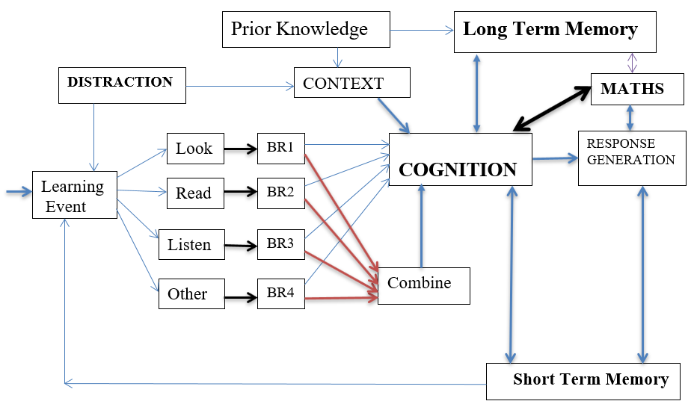
Figure 1. Basic mental processes involved in learning physics. Note the various feedback loops and the specific MATHS loops. BR refers to specific regions of the brain which process sensory signals.

A characteristic of passive learning of factual information is that the cognition may be minimal and will be followed by a loop to the next individual learning event, e.g. the next equation or sentence or paragraph in a book. In active learning directed to improving understanding there should be a “Response Generation” (which may be after several individual loop stages) which could take several forms and which could be expressed by writing or speaking or some other physical response (think of Archimedes jumping out of his bath and exclaiming “eureka”!). This response would be stored in short term memory and after more cognition transferred to long-term memory. In most of physics the use of maths is a major component of learning and this is shown in the diagram. Such maths may be very extensive and is the mechanism of logical deduction and clarification of the cognitive process. Feedback via loops involving response generation will refine and advance the results of cognition.
Not shown in the diagram are extra features to represent processes which deal with cases where there is a blockage caused by lack of understanding of the main sensory inputs or the results of cognition. When this happens the student needs to use library resources or an “explanation” from an instructor who has a good understanding of both the subject and the student’s difficulty. In laboratory work it can be the start of a new investigation involving measurements.
  - An Example Illustrating Interaction with other Students
The same methods can be extended to produce diagrams which include interactions with the minds of other individuals such as other learners and/or an instructor. To make such diagrams more useful they need to be simplified by omitting some links, e.g. to memory. Since there are many forms of active learning, many such diagrams could be designed to analyse the processes involved with the aim of improving our understanding of their advantages and disadvantages. For example, they make clear the importance of careful responses and the pointing out of faulty reasoning which can then be corrected. An example is the upward spiral of “Socratic Dialogue” teaching which can occur in tutorials and where feedback loops can be very effective.
They also help us to understand the process difficulties in group work encountered by particular students, e.g. with introverted personality. An example could be the difficulties experienced in some forms of active learning by a student who has “High Functioning Autism” (or more generally ASD, Autism Spectrum Disorder). Such students are fairly common amongst physics university students but the condition is often undiagnosed. They have a strong internal focus and thus difficulty in interacting with others. But this is often compensated by high ability in deep thinking, great accuracy and care over detail, and creative thinking. They are sometimes referred to as “Twice Exceptional” students to recognise that their creativity and care over detail makes them exceptional also in a positive way.
Figure 2 represents “Learning by Student Discussion Groups” following a prior reading assignment. These often involve students explaining or sharing knowledge and understanding. Such methodologies have the advantage of requiring a clear shift from passive to active by requiring short term responses, critical thinking and responses from students followed by rapid feedback from others. But such active learning methodologies have the potential disadvantage that some students may be misled or confused by interactions with persuasive peers who may have limited understanding and/or have erroneous views. This may cause real learning problems in students who are not confident of their own knowledge and understanding.
The loops involved consist of one student “i”, speaking followed by other students (shown as Student “j”) listening. Student “j” may think based on her/his prior knowledge and then in turn will speak. If student “j” has ASD then the thinking may be quite profound but she/he will find it difficult to form a response and may produce a delayed response or no response at all. This is shown in Fig. 2. The loop consists of other students listening and thinking about the response but they may do little listening and thinking and so may bypass the Think box. The way the loops may then operate is that the discussion may be dominated by just two students (“i” and “k”) who may just blurt out their opinions to impress others by being quick in responding. But for introverted students, quiet internal contemplation and precise rational thought processes can be more productive for them than discussions with extrovert peers whose pronouncements they find very difficult to challenge. So, this internal approach to learning should not be discouraged by the teaching methodology employed. Quiet contemplation should be allowed, indeed encouraged. This illustrates one of the dangers of such student discussion groups.

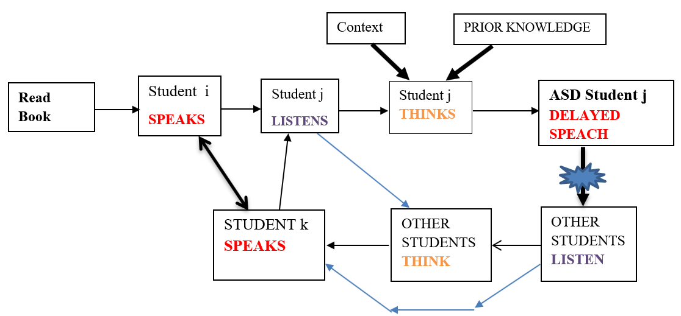
Figure 2. Learning by Peer Discussion. Note that a student with ASD may be excluded.

2.3 Special Features of Advanced Physics relevant to Active Learning and the above Diagrams
There are some particular features of physics which make it suited to such an analysis as described above. Physics is devoted at heart to achieving deep fundamental knowledge and understanding (at an internal personal level) of the physical world and the universe as a whole, indeed there is substantial evidence that this feature is very important in inspiring young people to study physics at university. Physics also involves going far beyond what can be directly observed (or inferred) and requires ways of thinking that question assumptions and challenge what seems obvious. The worlds of the very small and the very large are different to the world we live in so mental processes that have evolved in response to the need to succeed in everyday activities in our world may not be the most effective for learning physics; the brain is a product of evolution. Challenging questions that students may have should be addressed in discussions with experienced physicists. Finally, it should be noted that the general method of a systems based approach to modelling mental processes in learning is similar to the detailed simulation of physical processes involved in some experiments (e.g. experimental particle physics) using Monte-Carlo methods (e.g. [4]) where the comparison of real data with the outputs of such a simulation is very useful both for designing analysis methods and experiments and also for testing our understanding of the basic physics involved. It is a kind of “imitation game”, to borrow a phrase first used by Turing in a more profound but related context [5].
- Physics theatre to foster active learning in students (based on the presentation of Anonymous at the symposium)
Getting scientific notions perceived as beautiful, interesting and useful is a fundamental aspect to take into account to generate interest and curiosity in people towards science [6]. Although the presence of different stimuli (auditory, visual, of participation, of discussion…) added together in a multimodal learning structure determine the growth and the internalization of concepts, especially the scientific ones, at school we often tend to make a prevalent use of the auditory stimulus [7]. Student listens to the teacher's explanation with only few interventions of other factors so that, the relationship between students and teacher easily becomes authoritarian while the dominant language is verbal, descriptive and procedural [8]. This is particular true for the hard sciences, such as physics, that students often perceive as having only one “face” with little or no room for creativity. In order not to neglect the other faces of hard sciences an “A”, standing for Art, has been added to the STEM disciplines to propose an integrated STEAM approach to sciences [9].
In this perspective, scientific theatre deserves particular attention since it is an extremely useful tool to stimulate motivation from positive emotions [6 - 7, 10]. That is the reason why, in the last 15 years, the theatrical approach to physical themes has been explored by the group “Lo Spettacolo della Fisica” [11] founded by M. Carpineti, M. Giliberti and N. Ludwig of the Physics Department of the University of Milan.
The educational use of scientific theatre at school, with the direct involvement of students, can be proposed in various forms; typically, through improvisation, role-play or writing and recitation of a script. In the first case, students impersonate a role without a prior preparation and outline aspects and problems concerning a given scientific topic. In the role-play case, on the contrary, students impersonate specific roles after having reflected and studied in groups, at school and/or at home, reporting debates and controversies concerning scientific issues, often with social-ethical repercussions. Finally, and generally, the recitation of a script written by students focuses, instead, on historical or particular facts concerning a scientific event. Being much more challenging, this last activity gives students more freedom of expression and allows the development of more creativity.
There is, however, another common approach to the use of theatre, that starts from the vision of shows held by professional actors. The theatrical performance is often followed by a debate between actors and spectators on the covered topics, according to an idea that can be called that of “Theatre of Debate”. The purpose is to bring people, mostly children and young people, towards the world of science both, by generating enthusiasm and interest for the wonder of science and by considering the most debated social scientific issues of the moment. In particular, some theatre companies – not rarely also made up or with the advice of university physics professors – have become active by performing real physics experiments to show students the wonder of physics, or as a tool to discuss aspects that are often neglected at school and in textbooks, with new points of views to propose a change of perspective on the discipline.
Despite its value in teaching, the scientific theatre performed by theatre companies, cannot be a didactic theatre. On the contrary, it must be a theatre for everyone, not for schools, at least in the same sense in which the “Hamlet” by Shakespeare is for everyone: it has not been written for school; but, for its beauty and for the ideas it expresses, it is studied by everyone right at school.
Professional scientific theatre, in short, does not have to talk about physics in order to explain it or to divulge it, but has to reflect on what, perhaps, we humans have of most important: our vision of the world and of life, of which they are part, together, the things we know, the ways we know them and the position and meaning we give ourselves in relation to the world. In dramas and comedies there is a conflict that must be resolved by the interaction with the other characters. This fact keeps the viewer alert and active. If the conflict/game manifests itself in questions about physics, an emotional involvement may arise. This involvement often generates participation and, if opportunely stimulated, also an active interest towards physics itself.
  - Active learning starting from scientific theatre
While the desire to understand is in general natural, in most cases the possibility to understand is not spontaneous, but is to be learned, so that knowledge and culture can be internalized in a personal way that leads to the appropriation of concepts. When this happens, the conceptual change occurred makes the person become able to process the knowledge received and return it to society. It is a matter of fact that school are not, and cannot be, enough for this process to happen. In fact, culture is only partly scholastic and learning certainly does not end at school.
The Physics Education Division of the European Physical Society has recently highlighted the importance of learning physics for the whole life, even in informal contexts [9]. For this reason, schools have to open up and interact more and more with society. To help this interaction, formal, non-formal and informal education have to be in close synergy with each other while the person must be at the centre of the teaching process. In fact, the learning of physics in a formal context (i.e. at school) depends very much on what is said, read, seen, experienced about physics in contexts that are not formal. And, on the other hand, the way we teach physics at school has great repercussions on the social and cultural image of the physics itself.
Theatre can be an important tool for generating school-society-person interactions. In fact, it is able to develop scientific imagination, to help improve learning by using emotions in an effective way, to promote an approach to physics through the channel of affectivity and to enhance personal needs, thus diminishing cultural and gender discrimination by promoting a scientific culture that is more profound and even more human.
  - Theatre to bridge the gap between informal and school activities in Milan: an example
To foster active learning in students, the work proposed by the Physics Education research group of the University of Milan aims at creating a bridge among informal, non-formal and school activities. As an example, we briefly describe the general structure of a path concerning the electromagnetic spectrum.
- The first step (vision of a show held by professional) is the vision of “Light from stars” a physics theatre show, offered by “Lo spettacolo della Fisica”, written and performed by M. Carpineti, M. Giliberti and N. Ludwig (figure 3). In this show, the principal theme, that is the vision of the universe at various wavelengths, is embedded in those of the effectiveness of the scientific communication and of gender gap
- The second step is the participation of students and their teacher in the so-called PLS (Scientific Degree Plan) laboratory “The invisible colours at the edges of rainbow” (a non-formal activity) held at the physics department of the university of Milan. The laboratory (of about 3 hours) proposes students to explore in small groups the electromagnetic spectrum at the borders of the visible with simple experiments using thermal cameras and UV cams connected to tablets. Observing reality in the spectral regions of ultraviolet, near infrared and thermal infrared allows students to give a new meaning to the concepts of vision and heat and also to make many aspects, of calorimetry and thermodynamics related to heat transmission, “visible”.
- The third step is made of five (4-hours each) afternoon (after school) lab lessons at university in which also the physics teacher of the students is present. In the first, students discuss the way and the why a scientific theme has been dramatized the way it is in some physics shows, starting from (but not limited to) “Light from stars” that they have already seen. A publication created for this purpose by the EU project TEMI (Teaching Inquiry with Mysteries Incorporated) to which the Milan group participated, and concerning the show “Light mystery” – again by “lo Spettacolo della Fisica” – is also used (http://teachingmysteries.eu/wp-content/uploads/2016/04/LIGHT-MYSTERY-Theatre-Script-supporting-science-teaching-v3.pdf)

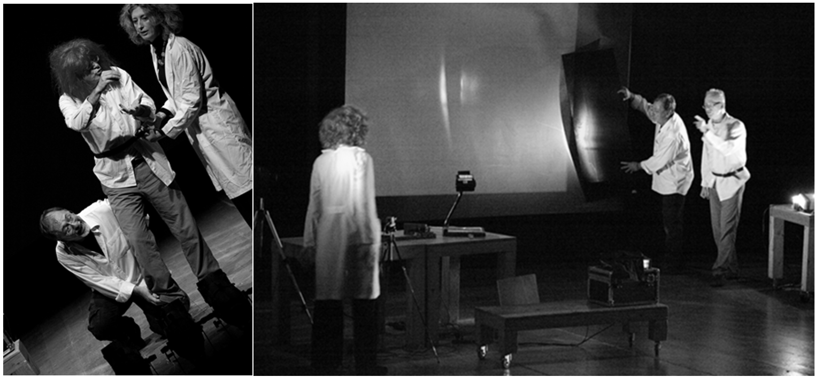
Figure 3. Two pictures of the show “Light from stars”. Credits: Fabrizio Favale.

The second lab lesson is dedicated to providing students with theatrical instruments, starting students with theatrical language, the use of their body and their voice and, in general, with basic elements of a “theatrical grammar”
The third and fourth lab lessons are dedicated to direct experimentation. Students divided into groups are asked to choose one or two themes related to UV and IR vision, to deconstruct the scientific theme and work to bring out various aspects of it in a theatrical way.
In the last lab lesson, students present their original work and discuss it with the other students of the lab and the lab teacher.
  - Comments and perspectives.
The attitude of the students in performing dramatization activities, proved to be positive in most cases, Many students reported having enjoyed and excited during the activity, some changed their idea from negative to positive on the scientific subject and appreciated the fact of seeing the same theme from several points of view. Even those who had no affinity with physics developed interest and felt involved. They felt to have learned something with a meaningful learning. But we in Milan believe we have to go even further and are working and planning to strengthen the theatrical activities with the formal ones at school with the creation and experimentation of a tutorial for developing lessons with lab activities about UV and near and far IR, as well as about the vision of colours (with the help of the master students Martina Mulazzi and her tutor in Bologna, Olivia Levrini). In fact, our experience lasting 15 years, with 7 dramas written and performed in more than 400 replicas, strongly suggests that in bridging the gap that is often present among formal, non-formal and informal education, scientific theatre can be really and extremely useful, but schools need a strong support to make students experiences grow also in a formal meaningful way.
- Active learning in teacher preparation for active learning in high schools (based on the presentation of Anonymous at the symposium)
Research shows that interactive engagement methods lead to better student learning gains than traditional methods (see for example [12 - 15]). In most cases, especially in high-schools with a population of students with very varied interests, the active engagement needs to be provided by the teacher. Therefore, we want to prepare our future teachers to use active engagement methods in their class. We choose ISLE (Investigative Science Learning Environment), because it actively engages students in all phases of learning/teaching process and it is also an epistemologically authentic approach. ISLE engages students in knowledge-generating activities that mimic the actual practices of physics, using the reasoning tools that physicists use when constructing and applying knowledge [16, 17].
Through the last decade, we gradually reformed the following courses at our department using ISLE as a theoretical framework: Didactics of physics (sequence of three one-semester courses), Communication of physics, Methodical practicum, Project work in science, How things work and Project laboratory. All courses are either compulsory or elective courses for pre-service physics teachers.
  - The ISLE Framework.
The ISLE-Investigative Science Learning Environment framework has been described in detail elsewhere [16 - 19]. It places strong emphasis on the epistemology of physics mimicking the process of how scientists acquire new knowledge (see figure 4). First, students make an observation of a phenomenon. Next, they design an observational experiment, which will help them observe patterns in the phenomenon. The patterns can be qualitative or quantitative. Then students propose explanations (hypotheses, models) for the observed patterns. The explanations can be either causal (relating cause and effect without referring to or describing a specific mechanism) or mechanistic (explaining the mechanism behind the phenomenon). The next phase is to test the explanations by proposing testing experiments, which should aim to reject one or more of the proposed explanations. In case of more explanations, the testing experiments should differentiate between them. It is crucial to predict the outcome of the experiments based on the proposed explanations before performing the experiment. If the outcome of an experiment does not agree with the prediction based on an explanation, then it is necessary to identify the assumptions made when making the prediction and test their validity. If they are valid, then the explanation can be rejected. The process is repeated until only one explanation remains that could not be rejected by the testing experiments. This is accepted as the best explanation so far. Then students can use this explanation (knew knowledge) to apply it in solving practical problems (application experiments). The description is simplified, but it is important to note that the process is neither linear nor cyclic.

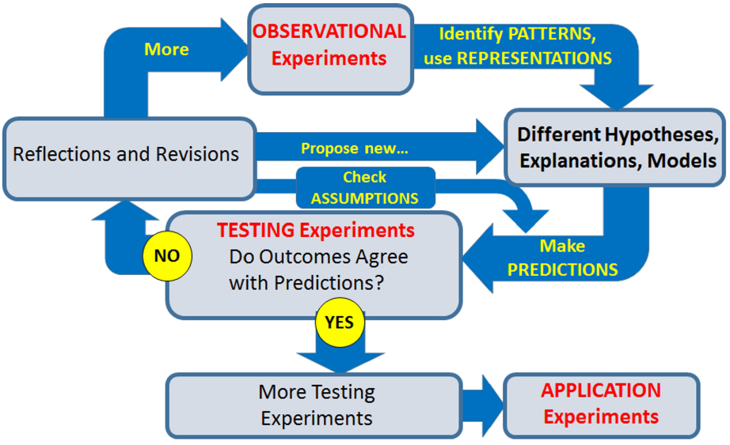
Figure 4. A simplified diagram of the ISLE process.

  - Didactics of physics
Didactics of physics is a three-level course. Using the ISLE framework, we reformed both lessons and recitations to be as actively engaging as possible. Our goal is to teach the way we would like our students to teach when they go to schools. Over the past 6 years, we have gradually transformed our lessons so that now we are using ISLE approach in every lesson. Before beginning each lesson, we carefully create the “need to know” [20], the motivation for learning the topic. Students work in small groups, solving both individual and group tasks following the ISLE process as described above. This way they experience the process of gradually building new physics knowledge (such as Newton’s laws, conservation laws etc.) in addition to the relevant pedagogical content knowledge (PCK). We encourage students to propose different explanations, even if they already know the accepted one. This helps them practice the step that is most challenging and motivating for students – testing the hypotheses. They have to propose testing experiments to reject some of the explanations, which helps them think about what testing experiments their students might propose. Later, when they do clinical practice in schools they often realize that high school students come up with similar ideas. We insist that the most important findings come from the class before being reiterated and structured by the instructor.
In cases when topics are too complex for students to come up with the correct explanations, we start from observations and identifying patterns but then create the need to know before “time for telling” [21].
In recitations, students also work in small groups. They solve problems on their own, often using the think-pair-share method, with the instructor providing guidance and assistance. Depending on the type of problem, students start solving the problem alone, before discussing with peers. The final solution is a consensus of the entire group, which distributes the responsibility and builds confidence in the solution. The type of problems reflects the ISLE philosophy as well. Since students are future teachers, many tasks involve evaluating solution or statements given by fictitious persons. These include common ideas and difficulties that students typically have. Students have to recognize productive ideas, even when embedded in incorrect answers and differentiate them from unproductive ideas. This way they develop tolerance and the ability to listen to others’ ideas. Students are often asked to suggest an intervention describing how they would respond in a particular situation. We encourage pre-service teachers to think what steps their students should do to come up with a correct understanding rather than them presenting the correct answer or explanation.
We also changed the way we assess students’ work. We put large emphasis on formative assessment and allow students to revise and improve their work without being punished for revisions by getting a lower grade [17]. Tasks are such that they reflect the emphases of the ISLE method and students are given a short time (typically less than 24 hours) to improve their work after we return them their tests giving them only an overall score without comments on what they need to improve. For the improved solution to be accepted, students need to identify what parts of their work are problematic (they are allowed to consult their peers) and write for each part the following: What did I do incorrectly, How to do it correctly, Why did I make the mistake and How did I learn to do it correctly.
Student practice is an essential component of every teacher preparation course. Our students participate in three types of practice: microteaching (also known as simulation of school lesson), sheltered practice in school (similar to Japanese lesson study [22]) and clinical practice in school.
In microteaching, student pairs prepare and conduct a micro-lesson using the textbook College Physics [23] and the accompanying book of activities, the Active Learning Guide [24] that are both following the ISLE approach to all topics. The focus of micro-teaching is in developing abilities to identify opportunities in the classroom, listen and pay attention to students’ ideas and react productively, while using tested material from the textbook and the Active Learning Guide. We emphasize the role of experiments, especially testing ones, in the epistemology of physics. We developed rubrics for microteaching, using the Scientific abilities rubrics developed by the Rutgers group [25, 26]. Rubrics help students prepare their lessons and allow us to evaluate them.
The sheltered practice has been reformed so that students plan a series of lessons, usually covering an entire topic, where each lesson is designed following the ISLE framework but also taking into account the national curriculum. This way, students have the opportunity to see how a series of lessons come together and gain a better understanding of the entire approach. The students then carry out the entire series of lessons in a real class of high-school students, with pairs of students carrying out each lesson. The other students from the program, the teaching assistant and the course leader observe each lesson from the back without interfering and afterwards we have a thorough analysis of the lesson.
In clinical practice, students spend five weeks in a school and have to carry out at least 13 independently conducted lessons, some of which are observed by the course leader or the teaching assistant. We try to place students with mentoring teachers that are familiar with ISLE and motivated to improve their teaching style.
The Didactics of physics course is complemented with the Methodical practicum course, which focuses on the technical and pedagogical aspects of experiments. In this case using the ISLE framework enables us to go beyond mere manipulation of experiments. Students do projects with an emphasis on familiarizing themselves with contemporary technology, however, they have to propose how each experiment can be used in the classroom, and provide a clear description of the learning goals and the role of the experiment in achieving these goals.
- Pre-service science teacher’s experiences of inquiry-based learning in socioscientific contexts (based on the presentation of Anonymous at the symposium)
UNESCO’s recent report “Rethinking Education: Towards a common global goal?” [27] reminds us that the changes that we face in the world today are characterized by new levels of complexity and contradiction. Today’s citizens need a deeper understanding of global societal challenges and their implications for themselves, their families and their communities. This requires a broader vision of an active, engaged and responsible citizenship for the 21st century, as described in the objectives of the Framework for Science Education for Responsible Citizenship [28]. These objectives are further highlighted in the OECD Education 2030 framework which aims to build a common understanding of the knowledge, skills, attitudes and values necessary to shape the future towards 2030 [29]. In order to equip today’s learners with agency and a sense of purpose, and the competencies they need, to shape their own lives and contribute to the lives of others we need to make changes to science education curricula, pedagogy and assessment practices and support science educators in embedding such approaches in their classroom.
  - Theoretical basis
Strategies for Active learning, as described by the GIREP Thematic group highlights that (https://girep.org/thematic-groups/sal.html):

In order to effectively learn Physics students should do more than just listen to a lesson. They should be engaged in actively reading, writing, posing and discussing questions, gathering data from different sources, building models and in solving problems ultimately aimed at developing their knowledge, skills and attitudes. In Active Learning students are basically engaged in two aspects: doing things and reflecting about the things they are doing.

Inquiry is widely regarded as an effective approach to engaging learners in active learning and developing the learner’s scientific knowledge and skills [30]. Inquiry teaching is student-centred and teacher-student collaboration is a central feature of the learning environment. The role of the teacher is to facilitate learning by asking questions and encouraging students to reflect on their current understanding. An inquiry based learning (IBL) in school science is based around students carrying out investigations including experimentation and secondary research. Inquiry in the context of socioscientific issues (SSI), which are contemporary and relevant scientific topics with moral or economic implications [31] has further been promoted to enhance student’s scientific literacy. SSIs center around a range of scientific, social or moral viewpoints, which may conflict with the students’ own views and thus makes them personally relevant to students [32]. This study presents a qualitative analysis of the impact of this active learning approach with physics pre-service teachers (PSTs) to address two research questions:
• What are the PSTs’ experiences of carrying out inquiry in the context of SSI as learners?
• What are the PSTs’ experiences of carrying out inquiry in the context of SSI as teachers?
  - Methodology
This research presents a study of the implementation of a series of workshops with 17 physics pre-service teachers (PSTs). The PSTs were in their second year of a four-year undergraduate BSc in Science Education programme which would qualify them to teach from physics and mathematics or chemistry or teaching at secondary level. The workshops were facilitated at the end of semester two, with the PSTs having completed their first in-school teaching placement (total of four weeks) at end of semester one.
The aim of this study was to develop the skills and knowledge of the PSTs as learners and develop their pedagogical approaches as teachers - to order to prepare them to use inquiry-based learning (IBL) approaches in SSI contexts as part of their teaching [33]. The PSTs’ co-planned and presented on a series of lessons that incorporated inquiry learning in their own SSI context. The learning outcomes of sessions focused on PSTS developing the skills of planning for engagement in science including identifying investigable questions, anchoring ideas/ phenomena and preparing casual explanations. PSTs were presented with one of six SSI contexts - gas laws, human vision, satellite communication, modern bridges, rail travel and wind energy.
After the second workshops PSTs were facilitated to reflect individually on their own learning experiences in terms of the skills of collaboration, communication and time-management. At the end of the workshop series, PSTs were asked to reflect on what was challenging about collaborating with their group to complete and present this plan.
  - Findings
Analysis of PSTs first reflection revealed that PSTs were engaged in actively involved in the tasks of reading, writing, posing and discussing questions, gathering data from different sources, and building models to support their development of content knowledge. However, it was evident that PSTs were easily able to report on what they did but needed additional support to develop their reflective practices. This is essential for future teachers, as Shulman [34, 35] states that deliberate reflections are needed in order for teachers to start developing their Pedagogical Content Knowledge (PCK).
At the end of the workshops, the PSTs showed evidence of having developed their own scientific knowledge and skills. In their reflections, they discussed what changes they would make to their classroom practices to extend and deepen student learning, e.g. how they would change the assessments used, how they would scaffold learning to develop conceptual understanding and what experimental investigations they would include. In particular, they expressed that they had increased understanding of the importance of reflection, e.g. one PST stated “I would add a section to teach the students how to reflect, at the time of writing the plan I didn’t think in enough depth about the student’s prior reflection skills”.
- Discussion and final remarks
Although the four contributions to this paper deal with different themes, they all give a wide-range view of active learning foundations, methodology and efficacy and are strongly grounded on research on these topics.
Particularly, the first contribution acknowledges that effectiveness of learning ultimately lies in the student’s mind being active in producing a response on a short time scale to an intellectual stimulus. This is particularly true of higher education in physics where the aims include the achievement of a deep understanding of cognitively challenging concepts and methods which go far beyond the accumulation of a large amount of factual information and skills; thus, implying that thinking is much more important than remembering or skill in accessing a large factual knowledge base. Research on the mental processes involved in learning and of student different learning styles is promising and can give useful hints to the educators and researchers interested in deepening this subject to improve their understanding of active learning pedagogical and psychological foundations. Also, a better understanding of situations where active learning shows to be not so effective with special students can be obtained, as active learning approaches should be adapted to the specific learning styles and psychological attitudes of those kind of students.
As the literature has shown in the last years, there are many active learning approaches and research is still needed to well understand their real efficacy in improving student conceptual knowledge and skill development. The second contribution discusses a novel approach to active learning, based on the involvement of students in scientific theatrical activities. Here, the idea is that scientific theatre can be an extremely useful tool to stimulate motivation by arousing positive emotions. In the theatrical approach to physical themes, students first come into contact with the scientific theatre with the direct experience of one or more physics shows, then discuss with physicists and/or theatre professionals the way in which a scientific theme can be dramatized, actively working on a chosen physics topic to bring out various aspects of it with theatrical methods. These activities prove to be effective in producing positive reactions in student attitudes toward science. Many students report beeing enjoyed and excited during the activities, some appreciated the fact of seeing the same theme from several points of view. Even those who had no affinity with physics developed interest and felt involved. They felt to have learned something with a meaningful learning.
While research on active learning has often focused on student needs and difficulties, it is undeniable that a focus on the role of the implementer of the active learning approaches, i.e. of the teacher, is at least equally needed. Many research results [36 – 38] highlight the difficulties teachers face when they are fronted with the need to take active learning to their classes. A lack of self-confidence with the new pedagogical methodologies typical of active learning and/or lack of comfort with the content to develop, time constraints in development of the new topics/methodologies, doubts about evaluation, personal beliefs on teacher/student role in teaching/learning and on Nature of Science are only some examples of these difficulties. They may be due to a traditional initial teacher education and must be fronted in order to improve active learning-based teaching, both from a pre-service and an in-service teacher education point of view.
The last two contributions to this paper deal with this aspect. In the third contribution challenges in the implementation of active learning methods in a way that teachers will be able to use in schools are also discussed, mainly in the view of future teacher personal beliefs about what teaching looks like. These beliefs are, in many cases, much different from what is required to effectively implement active learning methods. The contribution describes an implementation of active engagement methods used in high school physics teacher preparation courses, pointing out that for effective implementation it is crucial to find a well-researched and tested active engagement approach. To this aim, the well-known Investigative Science Learning Environment approach is chosen as a theoretical framework. It clearly emphasizes experiments and observations, which are well acknowledged as crucial for the epistemology of physics. It is also shown that looking at the experiments as observational, testing and application experiments helps students to think like scientists and teachers to make progress towards a real understanding of active learning meaning.
The focus of the research discussed in the fourth contribution is on pre-service science teacher’s experiences of inquiry-based learning. Particularly, a study reporting on an inquiry-based learning (IBL) approach carried out in context of socioscientific issues (SSI) with a cohort of pre-service physics teachers (PSTs) is discussed. The approach aims at developing the pre-service teacher’s knowledge and skills for adopting inquiry and SSI contexts in their classroom practices. The PSTs are facilitated to carry out their own inquiry and reflect on their experiences of the pedagogical approach and context of the SSI. The PSTs’ experience as teachers showed an increased awareness of the advantages of more student-centred active learning approaches and the need for teachers to have well-developed PCK with integrated knowledge of theory, practice and reflection [39]. This study highlights that deliberate reflections are needed by learners so they are not only active in doing things and but also active in reflecting about the things they are doing.
In conclusion, the four contributions here presented show that, despite the consistent amount of literature results related to active learning, research on this topic is still scientifically interesting for both educational researches and teachers. Closer attention should be deserved to aspects like the need for a better understanding of the pedagogical and psychological foundations of active learning, for deepening possible new ways to do “active learning”, possibly involving socially well-recognized channels, like theatre, and for more focus on teacher pre-service and in-service education aimed at helping teachers to effectively shape their beliefs on the teaching/learning processes and to properly appropriate of methods and contents fostering active learning.

- References
[1] Bonwell C C and Eison J A 1991 Active Learning: creating excitement in the Classroom. ASHEERIC Higher Education Report no. 1 (Washington DC: George Washington University)
[2] Fazio C 2019 in press Active learning methods and strategies to improve student conceptual understanding: some considerations from Physics Education Research Selected papers of the GIREP 2018 International Conference
[3] Redish E F 2014 Am. J. Phys. 82 537
[4] Akerib D S et al 2012 Nucl. Instrum. and Meth. 675 63
[5] Turing A M 1950 Computing Machinery and Intelligence, Mind 49 433-64
[6] Carpineti M et al 2006 Nuovo Cimento B 121 901
[7] Carpineti M, Giliberti M, Ludwig N 2016 Theatre as a means of supporting the teaching of science, Light Mystery, a script with added comments ISBN/EAN: 978-94-91760-19-8
[8] TEMI 2016 Available at http://teachingmysteries.eu/en.
[9] Position Paper on Physics Education V2012, EPN 43/6,
[10] Barbieri S et al 2015 Nuovo Cimento 38 86
[11] Lo spettacolo della fisica 2019 Available at http://spettacolo.fisica.unimi.it
[12] Hake R R 1998 Interactive-engagement versus traditional methods: A six-thousand-student survey of mechanics test data for introductory physics courses, Am. J. Phys. 66 64-74.
[13] Freeman S, Eddy S L, McDonough M, Smith M K, Okoroafor N, Jordt H, Wenderoth M P 2014 Active learning increases student performance in science, engineering, and mathematics Proc. of the National Academy of Sciences 111(23) 8410–15
[14] Von Korff J, Archibeque B, Gomez K A, Heckendorf T, McKagan S B, Sayre E C, …Sorell, L 2016 Secondary analysis of teaching methods in introductory physics: A 50 k-student study. Am. J.Phys 84(12) 969–74
[15] Waldrop M M 2015 The science of teaching science, Nat. 523 272-74.
[16] Etkina E 2015 Millikan award lecture: Students of physics—Listeners, observers, or collaborative participants in physics scientific practices? Am. J. Phys. 83 669-79.
[17] Brookes D, Etkina E, Planinsic G 2019 ISLE: An epistemologically authentic approach to student-centered inquiry learning, submitted to Phys. Rev. PER.
[18] Etkina E, Van Heuvelen A 2007 Investigative Science Learning Environment – A Science Process Approach to LearningPhysics. In E. F. Redish& P. J. Cooney (Eds.), Research – Based Reform of University Physics 1 (Retrieved from www.compadre.org/per/per_reviews/media/volume1/isle-2007.pdf)
[19] Etkina E, Brookes D T, Planinsic G (In press 2019). Investigative Science Learning Environment: Learn Physics by Practicing Science, In J.J. Mintzes and E.M.Walter, Eds. Active learning in college science: The case for evidence based practice. Berlin: Springer Nature.
[20] Knowles M S 1980 The Modern Practice of Adult Education (Englewood Cliffs NJ: Cambridge Adult Education).
[21] Schwartz D L and Bransford J D 1998 A time for telling Cogn. & Instr. 16 475
[22] Yoshida M 1999. Lesson study: A case study of a Japanese approach to improving instruction through school-based teacher development, Doctoral Dissertation: University of Chicago.
[23] Etkina E, Planinsic G, Van Heuvelen A 2019 College Physics 2nd Ed. (USA: Pearson Education)
[24] Etkina E, Brookes D, Planinsic G, Van Heuvelen A 2019 College Physics Active Learning Guide, 2nd Ed. (USA: Pearson Education)
[25] https://sites.google.com/site/scientificabilities/rubrics. Acquired on 22, Jan., 2019.
[26] Etkina E, Van Heuvelen A, White-Brahmia S, Brookes D T, Gentile M, Murthy S, Rosengrant D, and Warren A 2006 Scientific abilities and their assessment, Phys. Rev. ST Phys. Educ. Res. 2 020103
[27] UNESCO, Rethinking Education: Towards a common global goal? http://unesdoc.unesco.org/images/0023/002325/232555e.pdf (2015).
[28] Hazelkorn E, Ryan C, Beernaert Y, Constantinou C P, Deca L, Grangeat M, Karikorpi M, Lazoudis A, Casulleras R P and Welzel-Breuer M 2015 Science education for responsible citizenship. Report to the European Commission of the Expert Group on Science Education.
[29] OECD 2018, Learning Framework 2030. http://www.oecd.org/education/2030/learning-framework-2030.htm
[30] Bevins S and Price G 2016 Reconceptualising inquiry in science education. Int. J. Sci. Educ. 38(1), 17–29. https://doi.org/10.1080/09500693.2015.1124300
[31] Sadler T D 2009 Situated learning in science education: socio‐scientific issues as contexts for practice Stud. Sci. Educ. 45 1-42
[32] Zeidler D L and Nichols B H 2009 Socioscientific issues: Theory and practice. J. Elem. Sci. Educ. 21 49-58.
[33] Chadwick R 2018 Development and assessment of scientific literacy for secondary level science education PhD thesis Dublin City University.
[34] Shulman L 1986 Those who understand: knowledge growth in teaching. Educ. Res. 15(1) 4–14.
[35] Shulman L 1987 Knowledge and teaching: foundations of the new reform. Harvard Educational Review 57(1) 1–22.
[36] Mitchael J 2007 Faculty perceptions about barriers to active learning. Col. Teach. 55(2) 42-47
[37] van den Berg R 1999 The permanent importance of the subjective reality of teachers during educational innovation: A concerns-based approach. Am. Educ. Res. J. 36 (4) 879-906
[38] Adamson S L, Banks D, Burtch M, Cox III R, Judson E, Turley J B, Benford R and Lawson A E 2003 Reformed instruction and its subsequent impact on secondary school teaching practices and student achievement. J. Res. Sci. Teach. 40(10) 939-57
[39] Juhler M J 2018 Pre-service teachers’ reflections on teaching a physics lesson: How does Lesson Study and Content Representation affect pre-service teachers’ potential to start developing PCK during reflections on a physics lesson? NorDiNa 14 22-36.

