Interactive Lecture Demonstrations
Prediction Sheet—Diffraction of Light
Directions: Click here to download the Prediction Sheet on which you will record your predictions. Write your name at the top to record your presence and participation in these demonstrations. For each demonstration below write your predictions on this sheet before making any observations. You may be asked to send this sheet to your instructor.
Demonstration 1: A source emits plane waves of light that are incident on a plate with one slit cut into it, as shown on the right. The slit is very narrow compared to the wavelength of the light. Predict what you will see on the screen: one bright band the same width as the slit, uniform intensity, completely dark screen, alternating bright and dark lines, one bright band wider than the slit, one bright band narrower than the slit. In particular, predict the intensity at the center of the screen, directly opposite the center of the slit.  Only after you have made your predictions, click here to open the simulation. Select Slits. Then select light source  , Screen, Intensity and One slit. Push the button on the light source to start the simulation. Observe the light intensity pattern on the screen.  Compare your observations to your predictions and explain any differences. |  | 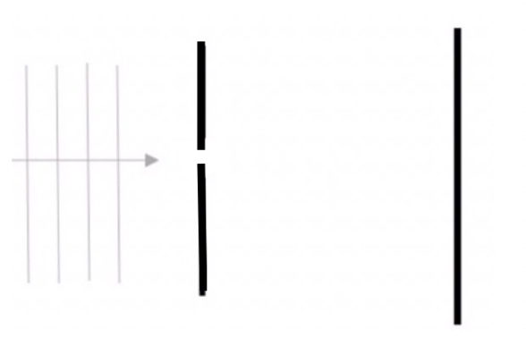
Demonstration 2: Suppose that the width of the slit is twice as wide as in Demonstration 1. Predict how this will affect the width of the intensity pattern on the screen: no change, wider, narrower.  Only after you have made your predictions, open the same simulation as in Demonstration 1. Make the slit width twice as wide as before, with everything else set as in Demonstration 1. Push the button on the light source to start the simulation. (You may want to switch the width of the slit several times and compare. Be sure to wait long enough for the intensity pattern to be steady.)  Compare your observations to your predictions and explain any differences. |  | 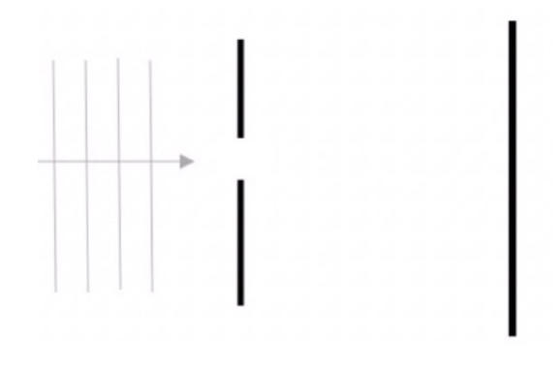
Demonstration 3: Suppose that the width of the slit is still twice as wide as it was in Demonstration 1, but now the wavelength of the light is longer. Predict how this will affect the width of the intensity pattern on the screen: no change, wider, narrower.
Only after you have made your predictions, open the same simulation as in Demonstration 2. Be sure the slit width and other settings are the same as in Demonstration 1. Push the button on the light source to start the simulation. After awhile use the frequency slider to adjust the wavelength of the light to the middle of the red (longer than green) and observe. (You may want to switch the wavelength several times and compare. Be sure to wait long enough for the intensity pattern to be steady.)
Compare your observations to your predictions and explain any differences. Explain in terms of path differences why increasing the wavelength might have this effect.

Demonstration 4: Suppose that the width of the slit is still twice as wide as it was in Demonstration 1, but now the wavelength of the light is shorter. Predict how this will affect the dimensions of the intensity pattern on the screen: no change, wider, narrower.
Only after you have made your predictions, open the same simulation as in Demonstration 2. Be sure the slit width and other settings are the same as in Demonstration 1. Begin with the frequency slider at the middle of the green. Push the button on the light source to start the simulation. After awhile use the frequency slider to adjust the wavelength of the light to the middle of the violet (shorter than green) and observe. (You may want to switch the wavelength several times and compare. Be sure to wait long enough for the intensity pattern to be steady.)
Compare your observations to your predictions and explain any differences. Explain in terms of path differences why decreasing the wavelength might have this effect.

Demonstration 5: Suppose that instead of a slit, there is a square hole cut in the plate. Predict how the intensity pattern on the screen will be different from that in Demonstration 1. Describe what you predict that you'll see on the screen.  Only after you have made your predictions, open the same. Select Diffraction. Select the square aperture , but don't change the other settings. Be sure the slit width and other settings are the same as in Demonstration 1. Push the button on the light source to display the light intensity pattern. Describe the intensity pattern you observe.  Compare your observations to your predictions and explain any differences. | 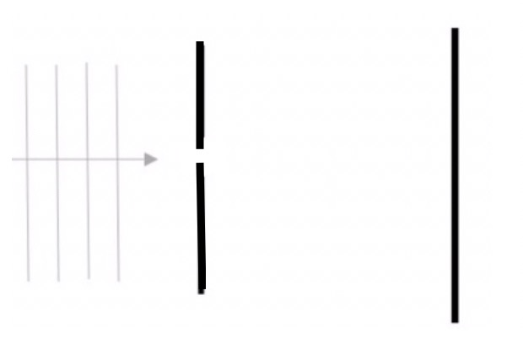
Demonstration 6: In Demonstration 5, predict what would happen to the intensity pattern if the horizontal dimension of the square were doubled, while the vertical dimension remained unchanged.

Only after you have made your predictions, use the slider to double the horizontal dimension. Describe what you observe, compare your observations to your predictions, and explain any differences. Compare to Demonstration 2.

Demonstration 7: In Demonstration 5, predict what would happen to the intensity pattern if the wavelength of the light were increased.

Only after you have made your predictions, use the slider to increase the wavelength of the light into the middle of the red region (longer than green). Describe what you observe, compare your observations to your predictions, and explain any differences. Compare to Demonstration 5.

Demonstration 8: Suppose now that instead of a square hole, there is a circular hole cut in the plate. Predict how the intensity pattern on the screen will appear now. (Hint: use your observations from Demonstrations 6 and 7. Describe what you predict that you'll see on the screen.

Only after you have made your predictions, select the circular aperture . Describe what you observe, compare your observations to your predictions, and explain any differences. Compare to Demonstration 6.

