Interactive Lecture Demonstrations
Prediction Sheet—Current in Series and Parallel Circuits

Directions: This is a Prediction Sheet where you will enter your predictions and answers. Write your name at the top to record your presence and participation in these demonstrations. For each demonstration below, write your prediction on this sheet before making any observations. You may be asked to send this sheet to your instructor.

Demonstration 1: In the top circuit on the right, bulb A is connected to a perfect battery (with no internal resistance). In the bottom circuit, Bulb B (which is identical to Bulb A) is added in series with bulb A, as shown.  Compare the brightness of Bulb A in the bottom circuit to the brightness of Bulb A in the top circuit. In the bottom circuit, compare the brightness of Bulb A to the brightness of Bulb B.  After you have made your predictions, download and view the video Series Brightness. | 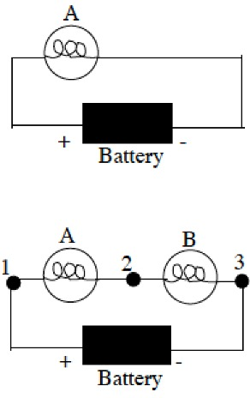
Demonstration 2: Compare the current at points 1 and 2 and in the bottom circuit.

After you have made your prediction, view the graphs of the measured currents at points 1 and 2 in the bottom circuit as the battery is connected and disconnected. How do they compare? Compare to your prediction and explain your obeservation.

Compare the current through Bulb A in the top circuit to the current through Bulb A in the bottom circuit.

After you have made your prediction, view the graphs of the measured currents through Bulb A in the top circuit and in the bottom circuit as the battery is connected and disconnected. How do they compare? Compare to your prediction and explain your observation.

Compare the current through the battery in the top circuit to the current through the battery in the bottom circuit.
After you have made your prediction, view the graphs of the measured currents through the battery in the top circuit and in the bottom circuit as the battery is connected and disconnected. How do they compare? Compare to your prediction and explain your observation.

Demonstration 3: In the top circuit on the right, Bulb A is connected to a perfect battery (with no internal resistance). In the bottom circuit, Bulb B which is identical to Bulb A is added as shown.  With the switch open, compare the brightness of Bulb A in the top circuit to the brightness of Bulb A in the bottom circuit.  With the switch closed, compare the brightness of Bulb A in the bottom circuit to the brightness of Bulb B.  After you have made your prediction, download and view the video, and compare the brightness of Bulb A with the switch open (top circuit) and with the switch closed (bottom circuit). Compare to your prediction and explain your observation.  Then compare the brightness of Bulb A in the bottom circuit (switch closed) to the brightness of Bulb B. Compare to your prediction and explain your observation. | 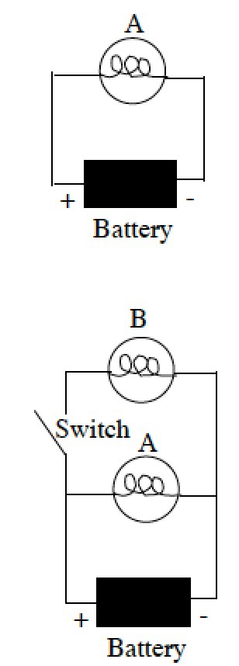
Demonstration 4: In the bottom circuit, with the switch closed, what do you predict for the current through Bulb B compared to the current through Bulb A.

After you have made your prediction, view the graphs of the measured currents through bulbs A and B in the bottom circuit as the switch is opened and closed. How do they compare? Compare to your prediction and explain your observation.

Predict how the current through the battery with the switch closed compares to the current through the Battery with the switch open.

After you have made your prediction, view the graph of the measured current through the Battery in the bottom circuit as the switch is opened and closed. How do they compare? Compare to your prediction and explain your observation.

With the switch closed, predict how the current through the Battery compares to the current through Bulb B.

After you have made your prediction, view the graphs of the measured current through the Battery in the bottom circuit as the switch is opened and closed. How do they compare? Compare to your prediction and explain your observation.

