Interactive Lecture Demonstrations
Prediction Sheet— Electromagnetic Induction, Faraday's Law and Lenz's Law
Directions: Write your name at the top to record your presence and participation in these demonstrations. For each demonstration below, write your prediction on this sheet before making any observations. You may be asked to send this sheet to your instructor.
Demonstration 1: A magnet is near a coil of wire. The switch, S₁, is initially open. When the switch is closed, predict if there will be a voltage induced across the coil?  Only after you have made your prediction, open the simulation: https://phet.colorado.edu/sims/html/faradays-law/latest/faradays-law_en.html  With the magnet at rest and the circuit of the coil complete, do you observe a current through the coil circuit? Does the magnet at rest near a coil induce a voltage across the coil? Compare to your prediction and explain. |  | 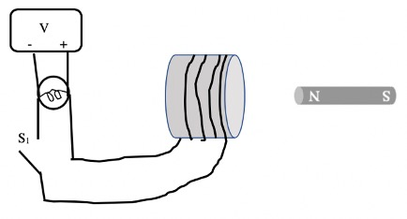
Demonstration 2: Switch S₁ is now closed and remains closed. The magnet is moved away from the coil of wire. Predict if there will be a voltage induced across the coil. If the magnet is moved away more quickly, predict how the induced voltage will change.  Only after you have made your prediction, use the same simulation as in Demonstration 1 to see what happens if you move the magnet away from the coil. Move the magnet until it is just opposite the right face of the coil, and then move it quickly toward the right. What is the sign of the induced voltage?  Compare your observations to your predictions and explain any differences. Use Faraday's law to explain the difference between Demonstration 1 and Demonstration 2. |  | 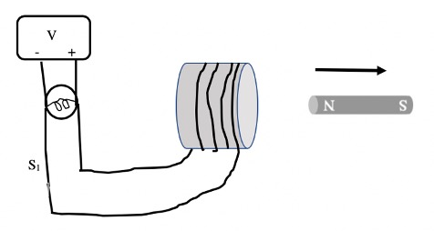
Demonstration 3: Switch S₁ remains closed. The magnet is now moved toward the coil of wire. Predict if there will be a voltage induced across the coil. What will the sign of the voltage be compared to Demonstration 2? If the magnet is moved toward the coil more quickly, predict how the induced voltage will change.  Only after you have made your prediction, use the same simulation as in Demonstration 1 to see what happens if you move the magnet toward the coil. Move the magnet until it is opposite the right face of the coil, and then move it toward the left. What is the sign of the induced voltage? Now move it more quickly. Is there any change in the voltage?  Compare your observations to your predictions and explain any differences. Use Faraday's law to explain the difference between Demonstration 2 and Demonstration 3. Use Lenz's law to explain any difference in signs between Demonstration 2 and Demonstration 3. |  | 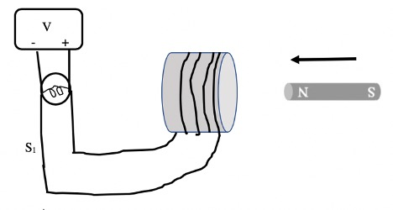
Demonstration 4: Switch S₁ remains closed. The magnet is now moved back and forth in front of the coil of wire. Predict the voltage induced across the coil over time. Predict what will happen to the voltage if the magnet is moved more quickly back and forth.  Only after you have made your prediction, use the same simulation as in Demonstration 1 to see what happens if you move the magnet back and forth in front of the coil. What is the behavior of the induced voltage? Also explore what happens when the magnet is moved more quickly back and forth.  Compare your observation to your prediction and explain any differences. Use Faraday's law and Lenz's law and your results from Demonstrations 2 and 3 to explain your observations. | 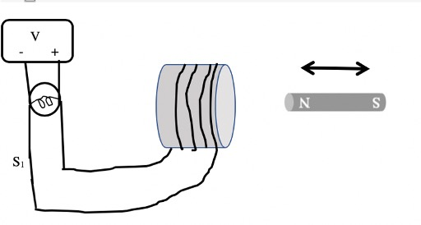
Demonstration 5: Switch S₁ remains closed. The poles of the magnet are now reversed and the magnet is moved toward the coil of wire. Predict if there will be a voltage induced across the coil. What will the sign of the voltage be compared to Demonstration 3?  Only after you have made your prediction, use the same simulation as in Demonstration 1 to see what happens if you move the magnet toward the coil. Reverse the poles of the magnet and then move it quickly toward the coil. What is the sign of the induced voltage?  Compare your observation to your prediction and explain any differences. Use Faraday's law and Lenz's law to explain the difference between Demonstration 3 and Demonstration 5. | 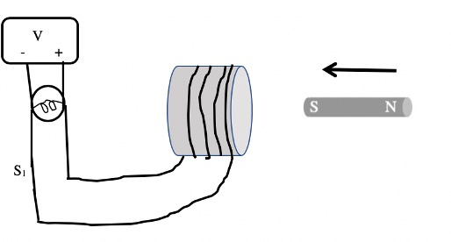
Demonstration 6: Switch S₁ remains closed. The poles of the magnet are now reversed (as in Demonstration 5) and the magnet is moved away from the coil of wire. Predict if there will be a voltage induced across the coil. What will the sign of the voltage be compared to Demonstration 2?  Only after you have made your prediction, use the same simulation as in Demonstration 1 to see what happens if you move the magnet toward the coil. Reverse the poles of the magnet and then move it quickly away from the coil. What is the sign of the induced voltage?  Compare your observation to your prediction and explain any differences. Use Faraday's law and Lenz's law to explain the difference between Demonstration 2 and Demonstration 5. | 