Interactive Lecture Demonstrations

Prediction Sheet— Heat Engine
Directions: Write your name at the top to record your presence and participation in these demonstrations. Record your predictions before making any observations. Your instructor may ask you to send in this sheet.

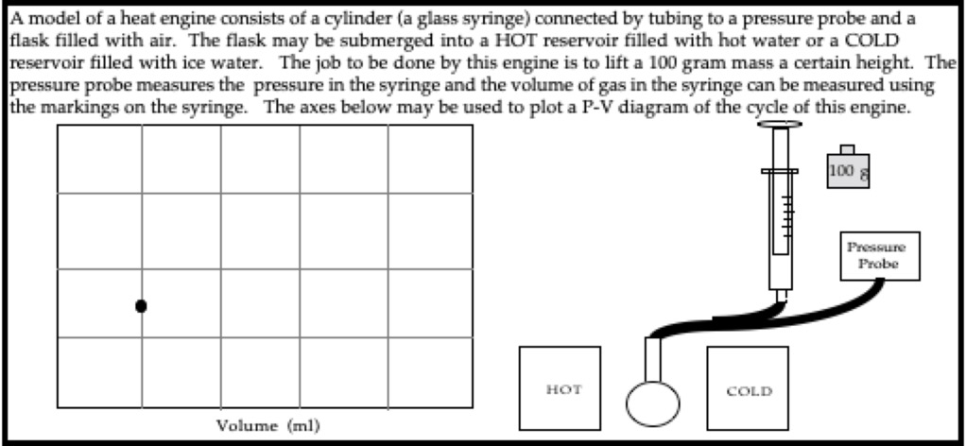
Click here to see a
photo of the heat
engine.
Pressure10⁵ Pa

Make your predictions for 1a through 1d on the axes above before observing the video.

Demonstration 1a: The cycle of the engine begins with the flask in the COLD reservoir, and the 100 gram mass off of the piston. This state is represented by the black dot on the axes above. Sketch on the axes the process that takes place when the mass is quickly put on top of the piston, with the flask left in the COLD reservoir. Describe in words what happens to the pressure and the volume of the air in the syringe.

Demonstration 1b: In the next process of the cycle, the flask is moved from the COLD reservoir to the HOT reservoir, with the mass left on top of the piston. Sketch this process on the axes. Describe in words what happens to the pressure and the volume of the air in the syringe.

Demonstration 1c: In the next process of the cycle, the mass is removed from the top of the piston, with the flask left in the HOT reservoir. Sketch this process on the axes. Describe in words what happens to the pressure and the volume of the air in the syringe.

Demonstration 1d: In the last process of the cycle, the flask is moved from the HOT reservoir back to the COLD reservoir with the mass removed from the top of the piston. Sketch this process on the axes. Describe in words what happens to the pressure and the volume of the air in the syringe.

Only after you have made all of these predictions, click here to download and view the video of the operation of the heat engine. (Note that the volume for each of the steps a through d is read from the syringe and beaker and entered manually at each step.)
Compare your predictions to your observations on the video and explain any differences.

Approximately what type of process (isobaric, isovolumetric, isothermal, or adiabatic) is each of the steps a through d? Explain each.
a:

b:

c:

d:

Only after you have made your predictions, click here to view what types of processes were involved in the operation of the heat engine.

Demonstration 2: How could you calculate the work done by the gas during this cycle? Show on your P-V diagram what represents the work done during the cycle.

Only after you have made your prediction, click here to observe how work is calculated on a P-V diagram. Explain how it is done.

