Interactive Lecture Demonstrations
Prediction Sheet—Image Formation with Lenses

Directions: Write your name at the top to record your presence and participation in these demonstrations. For each demonstration below, write your prediction on this sheet before making any observations. You may be asked to send this sheet to your instructor.

Demonstration 1: You have a converging lens. An object in the shape of an arrow is positioned a distance larger than the focal length to the left of the lens, as shown in the diagram on the right. Draw several rays from the head of the arrow and several rays from the foot of the arrow to show how the image of the arrow is formed by the lens.  Is this a real or a virtual image?  Only after you have made your prediction, click to observe the images ImageFormation1a and 1b. These show two light bulbs, at the top and bottom of the object, and a lens. Write any corrections to your prediction in the space at the right.  Now go to https://www.compadre.org/Physlets/optics/ex35_1.cfm and click on Initialize part (c). Drag the point source up and down on the object and describe how all of the rays from any point on the object converge to a point on the image.  Then go to https://www.compadre.org/Physlets/optics/ex35_2.cfm  First click on converging lens and then object with point sources. What happens to all the rays from the top of the object? Bottom?  Finally, select ray diagram, and compare it to the one you drew. | 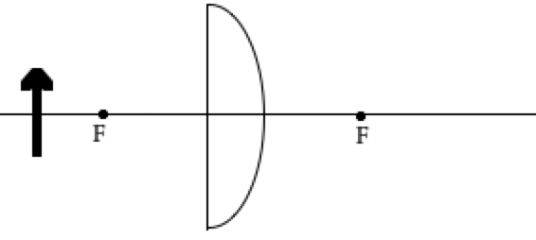

Demonstration 2: What will happen to the image if you block the top half of the lens with a card? Answer in words and show what happens on the diagram on the right by making any changes needed in the rays you drew in Demonstration 1.  Only after you have made your prediction, observe the images ImageFormation2. Then write any corrections to your prediction in the space at the right. | 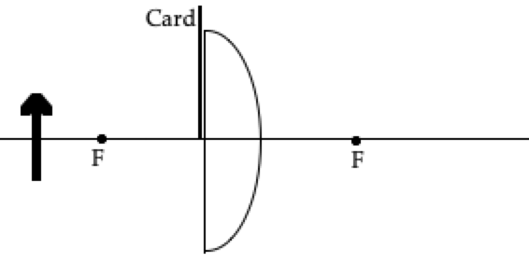

Demonstration 3: What will happen to the image if you block the top half of the object with a card? Answer in words and show what happens on the diagram on the right by making any changes needed in the rays you drew above for Demonstration 1.  Only after you have made your prediction, observe ImageFormation3. Then write any corrections to your prediction in the space at the right. How is this different than Demonstration 2? | 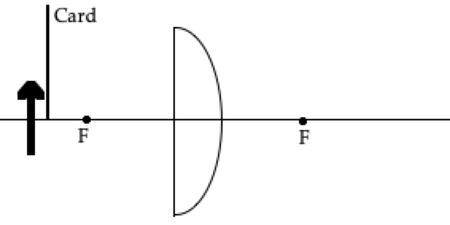

Demonstration 4: What will happen to the image if you remove the lens? Answer in words and show what happens on the diagram on the right by making any changes needed in the rays you drew above for Demonstration 1.  Only after you have made your prediction, observe ImageFormation4. Then write any corrections to your prediction in the space at the right.  Now go to https://www.compadre.org/Physlets/optics/ex35_2.cfm  First click on converging lens and then object with point sources. Then click on restart and then just object with point sources. How do the cases with the lens and without the lens differ? | 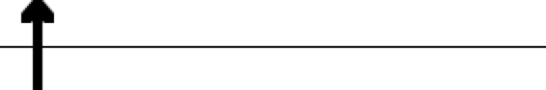

Demonstration 5: What will happen to the image if the object is moved further away from the lens? Will the position of the image change? If so, how?

Will the size of the image change? If so, how?

Will the image be real or virtual?

Only after you have made your prediction go to https://www.compadre.org/Physlets/optics/ex35_3.cfm Move the lens further from the object, and then write any corrections to your prediction below.

Demonstration 6: What will happen to the image if the object is moved closer to the lens (but is still further away than the focal point)? Will the position of the image change? If so, how?

Will the size of the image change? If so, how?

Will the image be real or virtual?

Only after you have made your prediction use https://www.compadre.org/Physlets/optics/ex35_3.cfm and move the lens closer to the object, and then write any corrections to your prediction below.

Demonstration 7: What will happen to the image if the object is moved closer to the lens so that it is closer to the lens than the focal point? Will the position of the image change? If so, how?

Will the size of the image change? If so, how?

Will the image be real or virtual?

Only after you have made your prediction go to https://www.compadre.org/Physlets/optics/ex35_3.cfm and move the lens closer to the object than the focal length, and then write any corrections to your prediction below.

