Interactive Lecture Demonstrations

Prediction Sheet— Introduction to Heat & Temperature
Directions: Click here to download the Prediction sheet on which you will record your predictions. Write your name at the top to record your participation in these demonstrations. For each demonstration, write your predictions on this sheet before making any observations. You may be asked to send this sheet to your instructor.
Demonstration 1: A small piece of metal has been raised to a high temperature, around 80-90°C. Sketch on the right your prediction for the temperature-time graph for the piece of metal cooling in the room air. Be sure to carefully sketch the shape of the curve.  What do you think the final temperature of the metal will be? Zero degrees C? Room temperature? Something different?  Only after you have made your predictions, click here to download the video and view the experiment. | 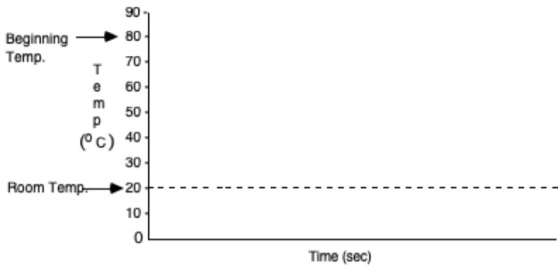
Compare the result to your predictions and explain any differences.

What does it appear that the final temperature of the metal will be? Explain.

Demonstration 2: Now the same piece of metal at a high temperature (around 80-90°C)) is immersed in an insulated cup filled with cool water (around 20°C). Sketch on the right your predictions for the temperature-time graphs of the piece of metal and the water in the cup. Be sure to carefully sketch the shapes of the curves.
What do you think the final temperature of the metal will be? (Zero degrees C? Midway between the initial temperatures of the water and the metal? Closer to the initial water temperature? Closer to the initial metal temperature? Other?)

What do you think the final temperature of the water in the cup will be?
Only after you have made your predictions, click here to download the video and view the experiment.
Compare the results to your predictions and explain any differences.

Compare the results to Demonstration 1 and explain any differences.

What does it appear that the final temperature of the metal will be? The water Explain.

Demonstration 3: Now a small film container filled with water at a high temperature (around 80-90°C) is immersed in an insulated cup filled with room temperature water (around 20°C). Sketch on the right your predictions for the temperature-time graphs of the film container of hot water and the water in the cup. Be sure to carefully sketch the shapes of the curves.  How do you think these graphs will compare to those in Demonstration 2? |  | 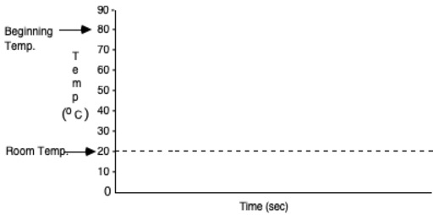
What do you think the final temperature of the water in the film container will be? (Zero degrees C? Midway between the initial temperatures of the water in the film container and water in the cup? Closer to the initial film container water temperature? Closer to the initial cup water temperature? Other?)

What do you think the final temperature of the water in the cup will be?
Only after you have made your predictions, click here to download the video and view the experiment.
Compare the results to your predictions and explain any differences.

Compare the results to Demonstration 2 and explain any differences.

What does it appear that the final temperature of the water in the cannister will be? The water? How is this different from Demonstration 2? Explain why.

Demonstration 4: Heat is transferred to water in a perfectly insulated cup (no heat can leak in or out) at a steady rate for 80 seconds, and then no more heat is transferred. Sketch on the right your prediction for the graph of the temperature of the water as a function of time.  Only after you have made your prediction, click here to download the video and view the experiment. (Note that each  on the graph represents an equal quantity of heat transferred by a heating coil immersed in the water.)  Compare the results to your predictions and explain any differences.  What is the mathematical relationship between the quantity of heat transferred to a substance and the change in temperature? |  | 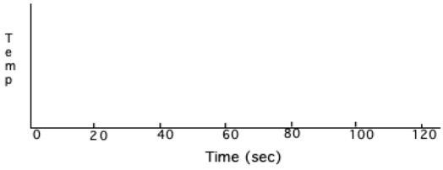
Demonstration 5: In Demonstration 1 you saw that a hot piece of metal cooled down in the room air. Hot water would do the same in an uninsulated cup. If you had a heating coil like in Demonstration 4 and wanted to keep some water in an uninsulated cup at about 80°C for 100 seconds in a room where the temperature is 20°C, what would you need to do? Explain, and sketch on the right how the graph would look.  Only after you have made your predictions, click here to download the video and view the experiment. (Note that each ^ on the graph represents an equal quantity of heat transferred by the heating coil immersed in the water.)  Compare the results to your predictions and explain any differences.  Why does then temperature remain more or less constant in this demonstration, while it increases in Demonstration 4? How is it possible to transfer heat without an increase in temperature? |  | 