Interactive Lecture Demonstrations

Prediction Sheet—Heat & Phase Changes
Directions: Write your name at the top to record your presence and participation in these demonstrations. For each demonstration, record your prediction(s) on this sheet before making any observations. You may be asked to send this sheet to your instructor.

Demonstration 1: Water initially at room temperature is in a perfectly insulated cup (no heat can leak in or out). During the first 20 seconds no heat is transferred to the water, and then during the next 60 seconds, heat is transferred at a steady rate. Then no more heat is transferred. Sketch below your prediction for the graph of the temperature of the water as a function of time.  Only after you have made your prediction, click here to download and view the video of the experiment. Compare the result with your prediction. (Note that each  on the graph represents the transfer of an equal amount of heat to the water.)  Explain the shape of the three sections of the graph: (1) no heat transferred, (2) heat transferred at a steady rate and (3) no heat transferred.  Why does the temperature rise at a steady rate as the heat is transferred to the water at a steady rate? | 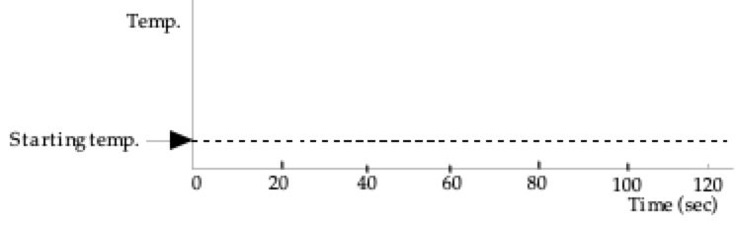
Demonstration 2: Heat is transferred at a steady rate to a mixture of water and ice at 0°C in a perfectly insulated cup (no heat can leak in or out). After the ice has completely melted, heat is still transferred for awhile. Sketch below your prediction for the graph of the temperature as a function of time.  Only after you have made your prediction, click here to download and view the video of the experiment. Compare the result with your prediction. (Note that each  on the graph represents the transfer of an equal amount of heat to the water.)  Is there any difference between the shapes of the two sections of the graph: (1) before all the ice has melted, and (2) after all the ice has melted. If they are different in shape, describe any differences and explain why.  Explain what is happening to the heat transferred before the ice melts? | 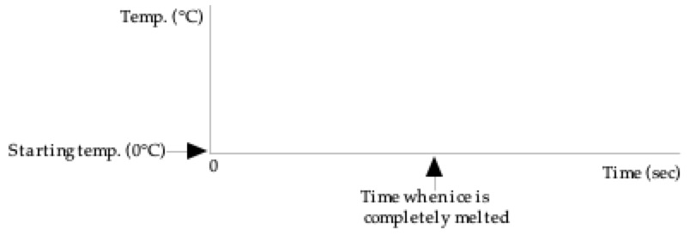
Demonstration 3: Heat is transferred at a steady rate to water initially at 80°C in a perfectly insulated cup (no heat can leak in or out). After the water starts boiling, heat is still transferred for awhile. Sketch below your prediction for the graph of the temperature as a function of time.  Only after you have made your prediction, click here to download and view the video of the experiment. Compare the result with your prediction. (Note that each on the graph represents the transfer of an equal amount of heat to the water.)  Is there any difference between the shapes of the two sections of the graph: (1) before the water begins boiling, and (2) after the water is boiling. If they are different in shape, describe any differences and explain why.  Explain what is happening to the heat transferred after the water is boiling? | 