Interactive Lecture Demonstrations
Prediction Sheet—Polarized Light
Directions: Write your name at the top to record your presence and participation in these demonstrations. For each demonstration, write your predictions on this sheet before making any observations. You may be asked to send this sheet to your instructor.
Demonstration 1: Consider a vertical object approaching a picket fence that is tilted by some angle θ with respect to that object. Will this object pass through the fence to the other side?  Suppose instead that the vertical object acts like a vector and is exactly equivalent to the sum of its components in any coordinate system. In terms of A (the length of the vector) and θ, how much of the vector will make it through the picket fence?  Only after you have made your predictions, click here to see the results. Compare the results to your predictions and explain any differences. | 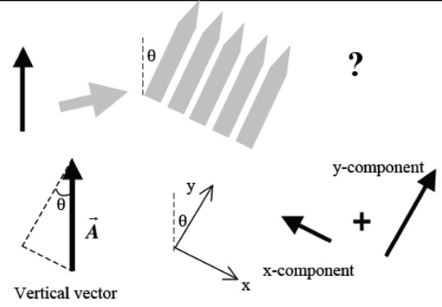
Demonstration 2: Consider un-polarized light, which consists of electromagnetic waves with an electric field vector, 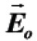, that oscillates in every transverse direction. A piece of Polaroid (polarizer) works just like the picket fence in Demonstration 1. If un-polarized light is incident on the polarizer (as shown), predict the direction of the electric field vector of the transmitted light.  If the incident intensity is I_{o}, estimate the transmitted intensity I.  Predict what will happen to the transmitted intensity as the polarizer is rotated through 90°.  Only after you have made your predictions, click here to see the direction of the transmitted electric field. Then click here to download and view a video of the experiment. Compare your observations to your predictions and explain any differences. | 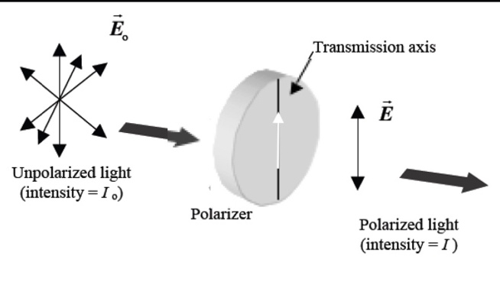
Demonstration 3: Unpolarized light is polarized vertically by passing it through a polarizer with its transmission axis vertical. It is then sent through a polarizer that has its transmission axis oriented horizontally. If the incident intensity is I_{o}, estimate the transmitted intensity I.  Only after you have made your prediction, click here to download and view a video of the experiment. Compare your observations to your predictions and explain any differences. | 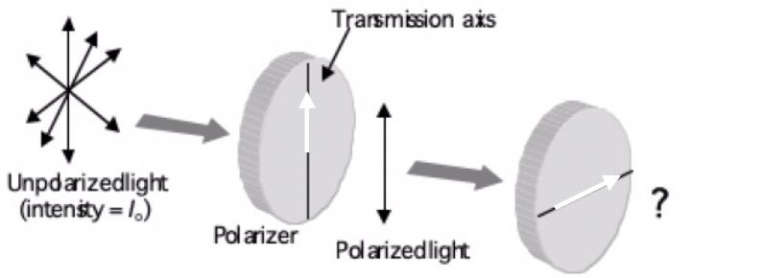
Demonstration 4: In Demonstration 3, a light intensity meter is placed to the right of the horizontal polarizer. Sketch on the axes to the right your prediction for the transmitted Intensity vs. angle as this polarizer is rotated through one complete revolution (360°).  Only after you have made your prediction, click here to see the graph of transmitted Intensity vs. angle. Compare your observations to your predictions and explain any differences. | 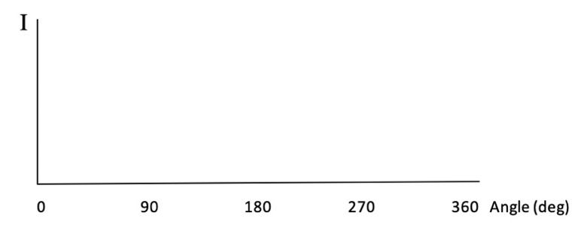
Demonstration 5: Unpolarized light is polarized vertically by passing through a polarizer with its transmission axis vertical. It is then sent through a polarizer that has its transmission axis rotated 45° to the vertical. Predict if any light will be transmitted through the 45° polarizer?  Only after you have made your prediction, click here to download and view a video of the experiment. Compare the results to your prediction and explain any differences. | 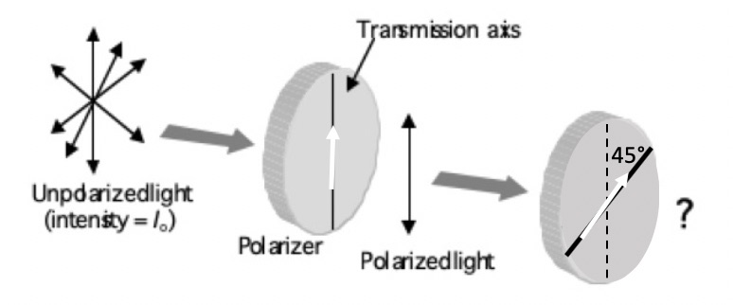
Demonstration 6: Now consider Demonstration 3 again with polarizer axes at 90° to each other. Suppose that a third polarizer is inserted in between the vertical and horizontal polarizers with its axis at 45° to the vertical. Will any light be transmitted through the last polarizer with its axis horizontal?  Only after you have made your prediction, click here to download and view a video of the experiment. Compare the results to your prediction. Explain your observation based on the model in Demonstration 1. | 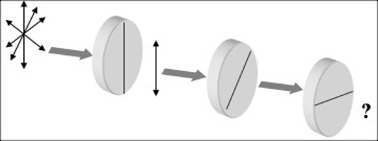
Demonstration 7: Unpolarized light reflects from the surface of a lake (or the glass windshield of a car) and passes through a polarizer. As the polarizer is rotated through 360º, the intensity of the transmitted light is measured with a light intensity meter. The graph shows the variation with angle Ø. (Note that the transmitted intensity is zero when Ø is zero degrees, that is when the transmission axis of the polarizer is vertical.) What do you predict about the polarization of the light that was reflected from the lake? (polarized, partially polarized, unpolarized?) Hint: use your observations in Demonstration 4.  Only after you have made your prediction, click here to download and view a video of the experiment. What do you conclude from the video? Compare to your prediction and explain. | 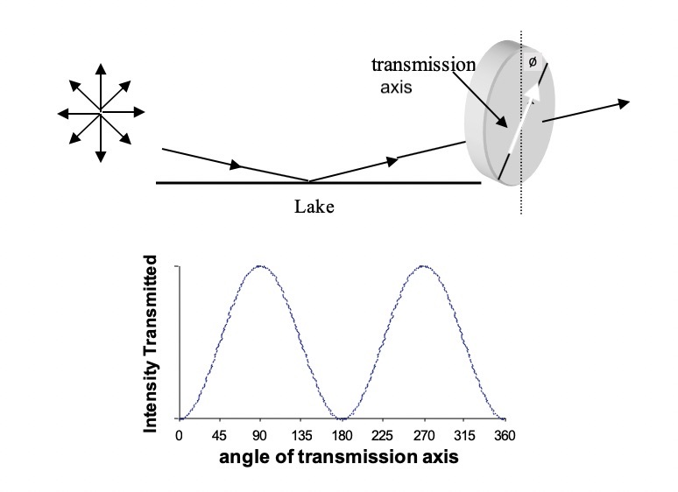
Demonstration 8—Consumer Alert: You purchase a pair of sunglasses advertised as having polarized lenses. How can you test whether they are actually polarized in the store without any fancy equipment? How should the transmission axis of the lenses be oriented so you get your money's worth (vertical, horizontal or some other angle)? Hint: use your observations in Demonstration 7.
Only after you have made your prediction, click here to see the result. Compare the result to your prediction, and explain any differences,

