Interactive Lecture Demonstrations
Prediction Sheet—Sound
Directions: Write your name at the top to record your presence and participation in these demonstrations. Make your predictions on this sheet before making any observations. You may be asked to send this sheet to your instructor.

Demonstration 1: A sound with constant pitch is emitted by a speaker and captured by a microphone. Predict the shape of the sound wave’s sound pressure vs. time at the location of the microphone.  Only after you have made your prediction, click here to download and view the video.  Compare the result to your prediction and explain any differences. |  | 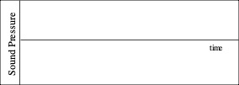
Demonstration 2: A sound with a higher constant pitch than the sound in Demonstration 1 is emitted by the speaker. Predict the shape of the sound wave’s sound pressure vs. time for several periods.  Only after you have made your prediction, click here to download and view the video.  Compare the result to your prediction and explain any differences. What property of a sound wave determines the pitch? |  | 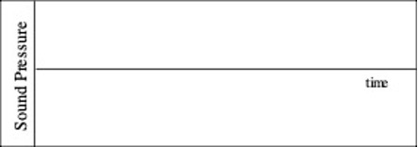
Demonstration 3: A louder sound with the same constant pitch as the sound in Demonstration 2 is emitted by the speaker. Predict the shape of the sound wave’s sound pressure vs. time for several periods.  Only after you have made your prediction, click here to download and view the video.  Compare the result to your prediction and explain any differences. What property of a sound wave determines the loudness (for two sounds with the same pitch)? |  | 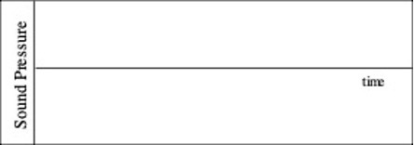
Demonstration 4: A person speaks in a normal tone of voice into a microphone. Predict the shape of the sound wave’s sound pressure vs. time for several periods.  Only after you have made your prediction, click here to download and view the video.  Compare the result to your prediction and explain any differences. How does this graph differ from the sounds with a constant single pitch? |  | 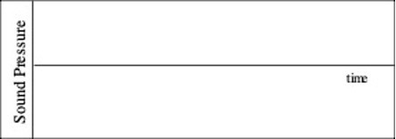
Demonstration 5: Two sounds with about the same volume but with slightly different pitches are played. Describe what you expect to hear:  Predict the shape of the sound pressure vs. time for the wave that represents the combined sound of the two pitches that are played.  Only after you have made your prediction, click here to download and view the video. Then click here to view the addition of the two sound waves.  Describe what you hear. Compare this with your prediction and explain any differences. How does this graph differ from the sounds with a constant single pitch? |  | 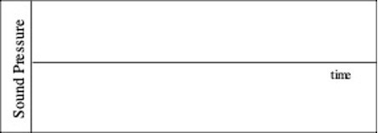
Demonstration 6: Two sounds with about the same volume are played, but one sound is a whole octave higher in pitch than the other. Describe what you expect to hear:  Predict the shape of the sound pressure vs. time for the wave that represents the combined sound of the two pitches that are played.  Only after you have made your prediction, click here to download and view the video. Then click here to view the addition of the two sound waves.  Describe what you hear. Compare this with your prediction and explain any differences. How does this graph differ from the sounds with a constant single pitch? | 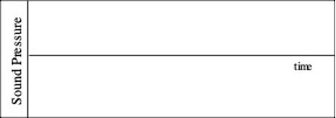
Demonstration 7: A short tapping sound is made into a long tube that is closed at one end. The sound pulse is recorded by a microphone near the opening, then travels down the tube, is reflected back and recorded again by the microphone. Click here to view the experimental setup. Then click here to see a recording of the actual sound collected by the microphone.
Given the data on the recording and that the length of the tube was 77 cm, how could you determine the approximate speed of sound in the tube? Record your calculation for the speed of sound in the space on the right.
Only after you have made your prediction, click here to view the calculation. Compare with your calculation.

