Interactive Lecture Demonstrations
Prediction Sheet—Interference of Light
Directions: Write your name at the top to record your presence and participation in these demonstrations. For each demonstration below write your predictions on this sheet before making any observations. You may be asked to send this sheet to your instructor.
Demonstration 1: A single point source of light is emitting waves. Sketch your prediction of the wave fronts of these waves. Describe the intensity of light that reaches the screen on the right.  Only after you have made your predictions, open the simulation: https://phet.colorado.edu/sims/html/wave-interference/latest/wave-interference_en.html Select Waves. When the Waves simulation opens, click on light source 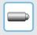 and Screen and then push the button on the light source to start the simulation.  Compare your observations to your predictions and explain any differences. | 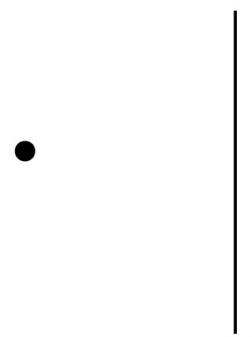
Demonstration 2: Now there are two point sources of light separated by a small distance. Both are emitting waves of the same wavelength, and in phase with each other. Sketch your prediction of the wave fronts of these waves. Show a wave front from each of the sources when it reaches the screen and describe the intensity of light on the screen on the right as you move from top to bottom.  Only after you have made your predictions, open the same simulation as in Demonstration 1, only this time select Interference. When the Interference simulation opens, again select light sources and Screen. Push the buttons on both light sources to start the simulation.  Compare your observations to your predictions and explain any differences. | 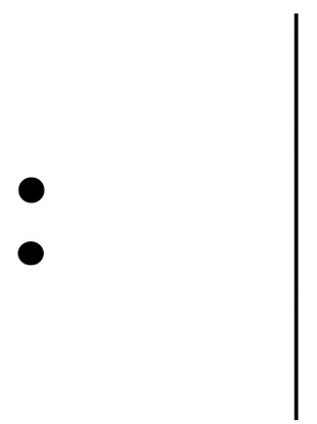
Demonstration 3: Suppose you have a meter that measures the electric field of a light wave as a function of time. You place it in front of the screen at the center point where the intensity is the brightest, as seen in Demonstration 2. On the axes, sketch your prediction for the electric field magnitude as a function of time. Also sketch your prediction if one of the light sources is turned off.  Only after you have made your predictions, open the same simulation as in Demonstration 2, again selecting Interference, light sources and Screen. Push the buttons on both light sources to start the simulation. After observing for awhile, move the meter out of the box at the top, and position one of the detectors just in front of the center point on the screen. Observe for awhile, and then turn off one of the light sources, and again observe for awhile.  Compare your observations to your predictions. Explain in terms of the lengths of the light paths from the two sources to the point on the screen why the intensity is bright at this spot on the screen when both light sources are on. |  | 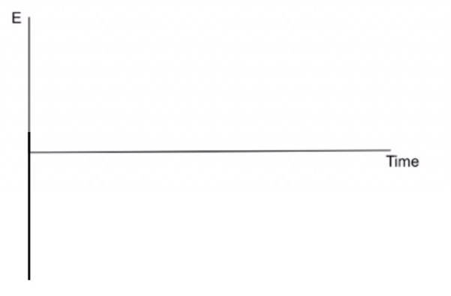
Demonstration 4: Now you place the detector in front of the screen at a point at the center of a region where the intensity is zero. On the axes, sketch your prediction for the electric field magnitude as a function of time. Also sketch your prediction if one of the light sources is turned off.  Only after you have made your predictions, open the same simulation as in Demonstration 3. Push the buttons on both light sources to start the simulation. After observing for awhile position one of the detectors at a point at the center of a region where the intensity is zero. Observe for awhile and then turn off one of the light sources, and again observe for awhile.  Compare your observations to your predictions. Explain in terms of the lengths of the light paths from the two sources to the point on the screen why the intensity is zero at this spot on the screen when both light sources are on. |  |  | 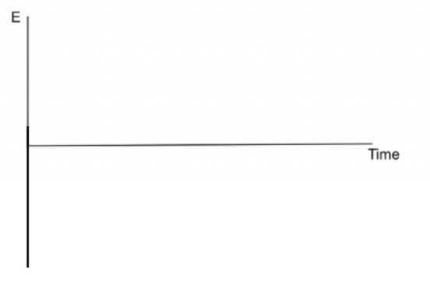
Demonstration 5: A source emits plane waves of light that are incident on a plate with two closely spaced parallel slits cut into it, as shown on the right. Predict what you will see on the screen: two parallel lines, uniform intensity, alternating bright and dark lines, completely dark screen. In particular, predict the intensity at the center of the screen, directly opposite the center of the two slits.  Only after you have made your predictions, open the same simulation as in the previous demonstrations. Select Slits. Then select light source 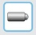 , Screen and Two slits. Push the button on the light source to start the simulation. Observe the light intensity on the screen.  Compare your observations to your predictions and explain any differences. Compare these observations to those in Demonstrations 2, 3 and 4. Are the intensity patterns on the screen similar? |  |  |  | 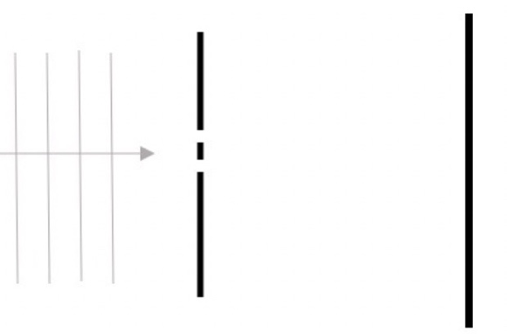
Demonstration 6: In Demonstration 5, what will happen to the intensity pattern on the screen if the spacing between the slits is decreased? What will happen to the intensity pattern on the screen if the spacing between the slits is increased?

Only after you have made your predictions, in the same simulation as in Demonstration 5, use the Slit Separation slider to make the separation half as large. Push the button on the light source and observe. Then, use the slider to make the separation twice as large as it was at the beginning. Observe the intensity on the screen. Describe the changes in both cases and compare to your predictions. Try to explain your observations in terms of the lengths of the light paths from the two slits to points on the screen.

Demonstration 7: In Demonstration 5, what will happen to the intensity pattern on the screen if the wavelength of the light is decreased? What will happen to the intensity pattern on the screen if the wavelength is increased?

Only after you have made your predictions, in the same simulation as in Demonstration 5, use the Frequency slider to make the light red (longer wavelength than green). Push the button on the light source and observe the intensity on the screen. (It will be helpful to note the position on the screen of one of the bright areas, e.g., the first from the center and see how it changes,) Then, use the slider to make the light violet (shorter wavelength than green). Observe the intensity on the screen. Describe the changes in both cases and compare to your predictions. Try to explain your observations in terms of the lengths of the light paths from the two slits to points on the screen.

