Interactive Lecture Demonstrations
Prediction Sheet—Magnetic Forces
Directions: Write your name at the top to record your presence and participation in these demonstrations. For each demonstration, write your predictions on this sheet before making any observations. You may be asked to send this sheet to your instructor.
Demonstration 1: A Van de Graaff generator is turned on, and it becomes positively charged. A magnet is brought near the generator as shown. Predict the direction of the force exerted by the magnet on the charges on the Van de Graaff.  Only after you have made your prediction, click here to see the magnetic force. Compare the result to your prediction and explain any differences. |  | 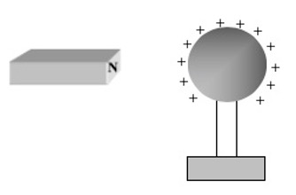
Demonstration 2: An insulated wire is in a magnetic field pointed into the screen. There is no electric current flowing through the wire. Predict the direction of the force exerted by the magnetic field on the electrons in the wire.  Only after you have made your prediction, click here to see the magnetic force. Compare the result to your prediction and explain any differences. |  | 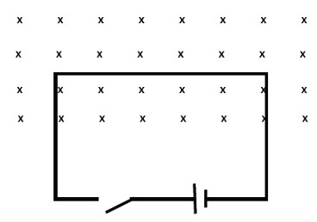
Demonstration 3: Now the switch is closed so that the current flows through the wire in the direction shown. Predict the direction of the force exerted by the magnetic field on the electrons in the wire. (Recall that the electrons move in the opposite direction to the conventional current.)  Only after you have made your prediction, open the simulation: https://www.compadre.org/Physlets/electromagnetism/illustration27_4.cfm  Click on the start button to start the electrons moving. Then click on uniform magnetic field pointing into the screen. Observe the force on the electrons and compare it to your prediction. Explain any differences. |  | 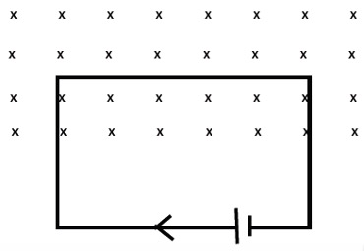
Demonstration 4: Suppose that the magnetic field is out of the screen. Now the switch is closed so that the current flows through the wire in the direction shown. Predict the direction of the force exerted by the magnetic field on the electrons in the wire.  Only after you have made your prediction, open the same simulation as in Demonstration 3.  Click on the start button to start the electrons moving. Then click on Switch the direction of the magnetic field (out of the page). Observe the force on the electrons and compare it to your prediction. Explain any differences. |  | 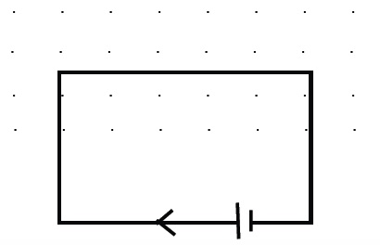
Demonstration 5: The magnetic field is again into the screen as in Demonstration 3. Now the battery is reversed so that the current flows through the wire in the opposite direction (as shown). Predict the direction of the force exerted by the magnetic field on the electrons in the wire.  Only after you have made your prediction, open the same simulation as in Demonstration 3.  Click on Restart and then on the start button to start the electrons moving. Then click on Change the direction the electrons are moving and Turn on the magnetic field into the page. Observe the force on the electrons and compare it to your prediction. Explain any differences. |  | 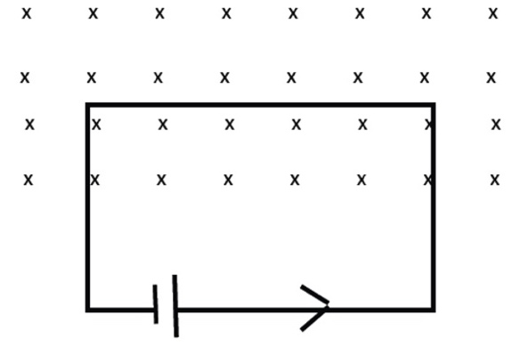
Demonstration 6: In each of the situations shown, a positive charge is moving in a magnetic field. Use the right-hand rule to predict the direction of the force or magnetic field (whichever is missing).
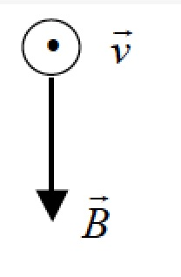 | 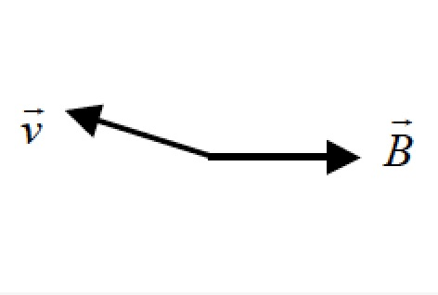 |  | 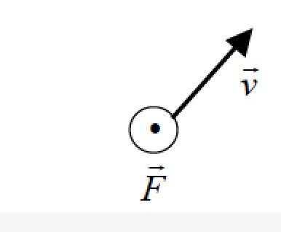
Only after making your prediction, click here to see the correct direction of the force. Compare to your prediction, and explain any differences. | Only after making your prediction, click here to see the correct direction of the force. Compare to your prediction, and explain any differences. |  | Only after making your prediction, click here to see the correct direction of the force. Compare to your prediction, and explain any differences.

Demonstration 7: In Dewmonstration 6, suppose that the chrge were negative. Again use the right-hand rule to predict the direction of the force or magnetic field (whichever is missing).
 | 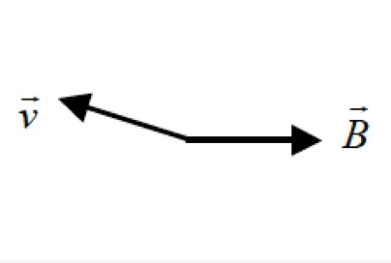
Only after making your prediction, click here to see the correct direction of the force. Compare to your prediction, and explain any differences. | Only after making your prediction, click here to see the correct direction of the force. Compare to your prediction, and explain any differences. | Only after making your prediction, click here to see the correct direction of the force. Compare to your prediction, and explain any differences.

