Interactive Lecture Demonstrations
Prediction Sheet—Kinematics 1—Human Motion
Directions: Write your name at the top to record your presence and participation in these demonstrations. For each demonstration below, write your prediction on this sheet before making any observations. You may be asked to send this sheet to your instructor.

Demonstration 1: The positive direction is toward the right.
(A) Sketch below on the left axes your prediction of the position-time graph for a person moving to the right at a steady (constant) velocity. On the right axes sketch your prediction for a person moving to the left at a steady (constant) velocity.
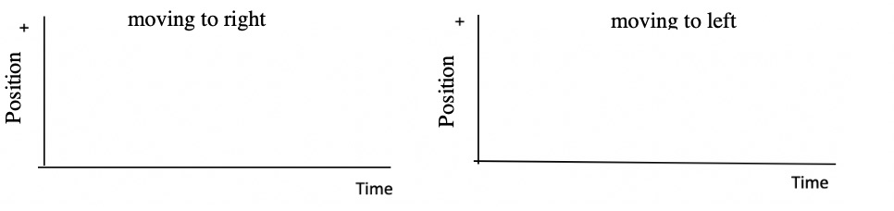
(B) Sketch below on the left axes your prediction of the velocity-time graph for a person moving to the right at a steady (constant) velocity. On the right axes sketch your prediction for a person moving to the left at a steady (constant) velocity.

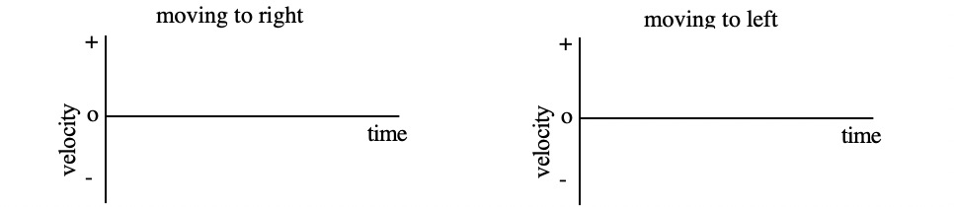
Only after you have made your predictions, open The Moving Man simulation:
https://phet.colorado.edu/sims/cheerpj/moving-man/latest/moving-man.html?simulation=moving-man
On the upper left, select Charts. Remove the Acceleration graph by clicking on the  in the upper righthand corner. Use the slider to set the velocity at around +1 m/s. Click on  to start graphing. When the man reaches the right limit and stops quickly move the velocity slider to about -1 m/s. When the man reaches the origin again, click on  to stop graphing.

1. Compare your observed position-time graphs to your predictions. If they don't agree, explain.

2. On a position-time graph, what tells you if the motion is in the positive or negative direction? Explain.

3. Compare your observed velocity-time graphs to your predictions. If they don't agree, explain.

4. On a velocity-time graph, what tells you if the motion is in the positive or negative direction? Explain

Demonstration 2: The positive direction is toward the right. Sketch on the axes below your predictions for the position-time and velocity-time graphs of a person to the right at approximately three times the speed of Demonstration 1.
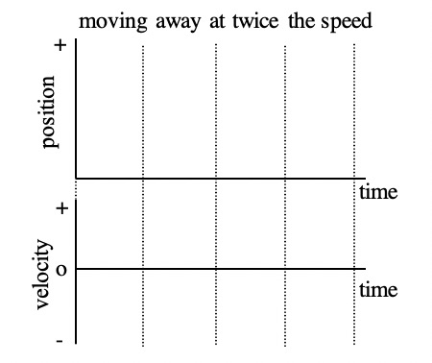 | Describe in words your prediction of how the position-time  graph changes when the speed is three times as fast.  Describe in words your prediction for how the velocity-time  graph changes when the speed is three times as fast.
Only after you have made your predictions, use The Moving Man simulation to test them. Click on and then.Again, remove the Acceleration graph by clicking on the  in the upper righthand corner. Use the slider to set the velocity at around +1 m/s. Click on  to start graphing. When the man reaches the right limit and stops, quickly slide him back to the origin and click on to stop graphing. Use the slider to set the velocity at around +3 m/s, then click on to start graphing, and stop when he reaches the right limit.
1. Compare your observed position-time graphs for the original motion and for moving three times as fast, and also compare to your predictions. What is different?

2. On a position-time graph, what tells you if the motion is fast or slow? Explain.

3. Compare your observed velocity-time graphs for the original motion and for moving three times as fast, and also compare to your predictions. What is different?

4. On a velocity-time graph, what tells you if the motion is fast or slow? Explain.

Demonstration 3: Sketch on the axes below prediction of the velocity-time graph produced when a person—
• walks in the positive direction slowly and steadily for 6 seconds
• then stands still for 6 seconds
• and then walks in the negative direction steadily about twice as fast as before

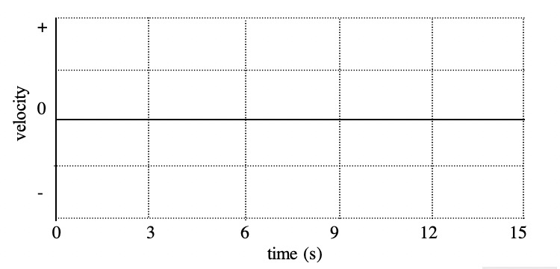
Only after you have made your predictions use The Moving Man simulation to test it. Click on and then.
Again, remove the Position and Acceleration graphs by clicking on the in the upper righthand corner of each. Use the slider to set the velocity at around +1 m/s. Click on to start graphing. After 6 sec, click on to stop graphing. Use the slider to reset the velocity to 0, start graphing, and stop after 6 more sec. Use the slider to reset the velocity to about -2 m/s, start graphing, and stop after 6 more sec. Be sure to keep this graph for use in Demonstration 4.

Compare your observed velocity-time graph to your prediction. If they don't agree, explain why.

Demonstration 4: Predict the position-time graph for the motion in Demonstration 3 on the axes below. (Align the distance and velocity graphs correctly in time.)
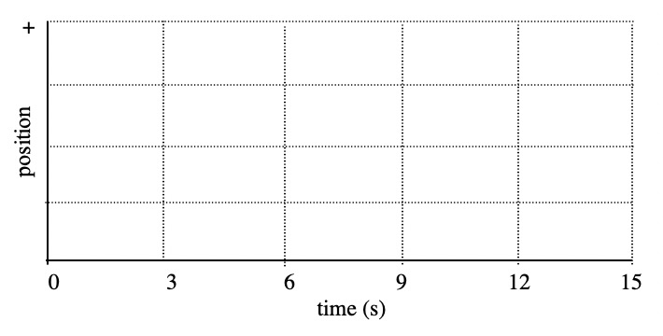

Only after you have made your predictions return to The Moving Man simulation to test it. Click on to display the position-time graph for this motion.
Compare this observed position-time graph to your prediction. If they don't agree, explain why.

