Interactive Lecture Demonstrations

Prediction Sheet—Kinematics 2—Changing Motion

Directions: Write your name at the top to record your presence and participation in these demonstrations. For each demonstration below, write your prediction on this sheet before making any observations. You may be asked to send this sheet to your instructor.

Demonstration 1: On the left velocity axes below sketch your prediction of the velocity-time graph of the man beginning at the origin and moving to the right at a steady (constant) velocity. On the left position axes below sketch your prediction of the
position-time graph for the same motion.
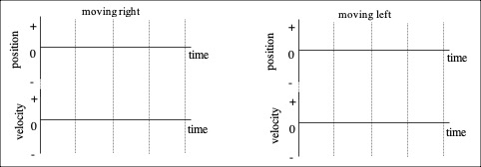
Only after you have made your predictions, open The Moving Man simulation:
https://phet.colorado.edu/sims/cheerpj/moving-man/latest/moving-man.html?simulation=moving-man
In the upper left, click on Charts. Then remove the acceleration graph by clicking on the on the right side of the graph. Use the Velocity slider to set the velocity at about +2 m/s. Click on  to start graphing and click on  to stop when he reaches the right barrier.
Compare the graphs to your predictions and explain their shapes.

Demonstration 2: On the right velocity axes above sketch your prediction of the velocity-time graph for the man beginning at the origin and moving to the left at a steady (constant) velocity. On the right position axes above sketch your prediction of the position-time graph for the same motion.
Only after you have made your predictions, test them with The Moving Man simulation. First click on  and then to reset everything. Again remove the acceleration graph by clicking on the on the right side of the graph. Use the Velocity slider to set the velocity at about -2 m/s. Click on to start graphing and click on to stop when he reaches the left barrier.
Compare the graphs to your predictions and explain any differences with motion toward the right in Demonstration 1.

On a position-time graph what represents the direction of motion?

On a velocity-time graph what represents the direction of motion?

Demonstration 3: Sketch on the axes on the right your predictions for the velocity-time and acceleration-time graphs of the man to the right and speeding up at a steady rate.  Only after you have made your predictions, test them with The Moving Man simulation. (NOTE: Human motion is actually inherently not steady and involves jerks and changes in the acceleration.) First click on and then to reset everything. Remove the position graph by clicking on the on the right side of the graph. Use the Acceleration slider to set the acceleration at about +3 m/s². Click on to start graphing and click on to stop when he reaches the right barrier.  Compare the graphs to your predictions and explain any differences. Explain the shapes of your graphs.  On a velocity-time graph what tells you that the object is speeding up at a steady rate? | 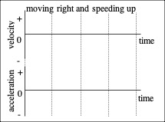
Demonstration 4: Sketch on the axes on the right your predictions for the velocity-time and acceleration-time graphs of the man moving to the right and slowing down at a steady rate.  Only after you have made your predictions, test them. First click on and then to reset everything. Remove the position graph by clicking on the on the right side of the graph. Use the Acceleration slider to set the acceleration at about -3 m/s². Use the Velocity slider to set the initial velocity to about + 6 m/s. Click on to start graphing and click on to stop when he momentarily stops moving.  Compare the graphs to your predictions and explain any differences. Explain the shapes of your graphs.  How does a velocity-time graph for slowing down differ from one for speeding up? | 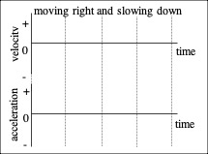
Demonstration 5: There's a very strong wind blowing toward the left. The man leaps forward and starts running toward the right but the wind slows him down and eventually pushes him back to the left. Sketch on the axes on the right your predictions for the velocity-time and acceleration-time graphs of the man moving to the right, slowing down at a steady rate, coming to rest momentarily and then moving to the left, speeding up at a steady rate.  Only after you have made your predictions, test them. First click on and then to reset everything. Remove the position graph by clicking on the on the right side of the graph. Use the Acceleration slider to set the acceleration at about -3 m/s². Use the Velocity slider to set the initial velocity to about + 6 m/s. Click on to start graphing and click on to stop when he stops at the left barrier.  Compare the graphs to your predictions and explain any differences. Explain the shapes of your graphs.  Compare the acceleration at the moment he reverses his motion to that before and after that time. Explain why the acceleration has this value. | 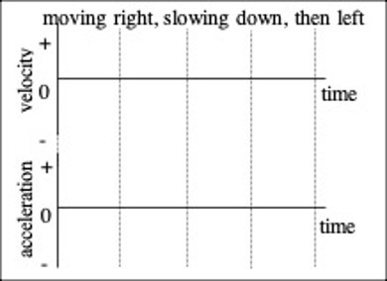
Demonstration 6: A cart with low friction is given a push up  an inclined ramp. It rolls up slowing down, reaches its highest point, and then rolls back down again. Sketch on the axes on the right your predictions for the velocity-time and acceleration-time graphs of the cart moving up the ramp, slowing down at a steady rate, coming to rest momentarily and then moving down the ramp, speeding up at a steady rate.  Only after you have made your predictions, test them. Download the movie by clicking CartRamp. View the movie and the acceleration-time and velocity-time graphs.  Compare the graphs to your predictions and explain any differences. Explain the shapes of your graphs.  Compare the graphs to those in Demonstration 5. Explain any similarities.  Compare the acceleration at the moment the cart reverses its motion to that before and after that time. Explain why the acceleration has this value. | 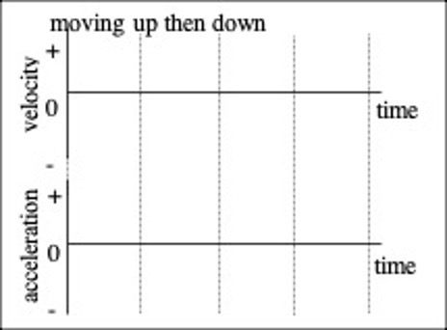
Demonstration 7: A ball is tossed straight up in the air. Assuming that air resistance is very small, sketch on the axes on the right your predictions for the velocity-time and acceleration-time graphs of the ball moving up, coming to rest momentarily and then moving down.  Only after you have made your predictions, test them. Download the movie by clicking TossedBall. View the movie and the acceleration-time and velocity-time graphs.  Compare the graphs to your predictions and explain any differences. Explain the shapes of your graphs.  Compare the graphs to those in Demonstrations 5 and 6. Explain any similarities.  Compare the acceleration at the highest point of the ball's motion to before and after that time. Explain why the acceleration has this value. | 