Interactive Lecture Demonstrations
Prediction Sheet—Relection and Refraction of Light
Directions: Write your name at the top to record your presence and participation in these demonstrations. For each demonstration below, write your prediction on this sheet before making any observations. You may be asked to send this sheet to your instructor.
Demonstration 1: Light is incident as shown on a plane mirror, like the one in your bathroom. The light ray is in the plane of this paper. Sketch the normal to the surface of the mirror at the point where the light ray hits the mirror. Predict the direction of the reflected ray and sketch it on the diagram. Must the reflected ray be in the plane of the paper?  Only after you have made your prediction, click here to see the correct diagram. Compare to your prediction and explain any differences. |  |  | 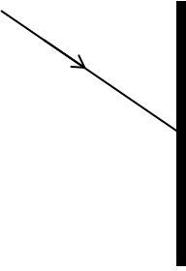
Demonstration 2: You are standing fairly close to the front of the mirror in your bathroom, and you see your image in the mirror. Sketch a stick figure prediction of your image on the diagram. Be sure to carefully show  • The position of your image  • The direction your image is facing  • The height of your image  • Mark with arrows on your image about how much of your body you will actually be able to see  Only after you have made your predictions, click here to see the correct diagram. Compare to your predictions and explain any differences. | 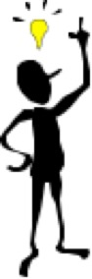
Demonstration 3: A light ray is incident on the surface of a slab of glass. Which has a larger index of refraction—air or glass?  Sketch on the diagram your predictions of the reflected ray and transmitted ray.  Only after you have made your predictions, open the simulation: https://phet.colorado.edu/sims/html/bending-light/latest/bending-light_en.html Click on Introduction Select the index of refraction for glass for the bottom slab, adjust the angle of incidence of the laser beam so that it is approximately like the diagram on the right (rotated by 90°, of course). Push the button to turn on the laser. Compare to your predictions and explain any differences. |  | 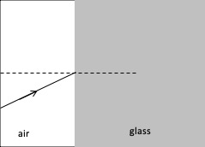
Demonstration 4: A light ray is incident normally on the surface of a slab of glass. Predict approximately what percentage of the incident light is reflected (close to 100%, close to 50% or much smaller than 50%).  Predict approximately what percentage of the incident light is transmitted (close to 100%, close to 50% or much smaller than 50%).  Only after you have made your predictions, open the same simulation as in Demonstration 3. Use the Intensity Meter to measure the reflected and transmitted intensities. (In order to measure the reflected intensity, you'll need to tilt the lases slightly away from normal incidence on the glass slab.)  Compare to your predictions and explain any differences. |  | 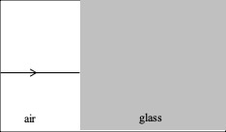

Demonstration 5: Suppose that the light ray is traveling in the glass and incident normally on air. Predict approximately what percentage of the incident light is reflected—the same as in Demonstration 4, or, if different, how much?  Predict approximately what percentage of the incident light is transmitted—the same as in Demonstration 4, or, if different, how much?  Only after you have made your predictions, open the same simulation as in Demonstrations 3 and 4. Change the indexes of refraction so that glass is on top and air on the bottom. Use the Intensity Meter to measure the reflected and transmitted intensities. (In order to measure the reflected intensity, you'll need to tilt the laser slightly away from normal incidence on the glass slab.) Compare to your predictions and explain any differences. | 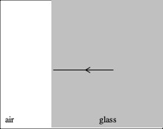
Demonstration 6: A light ray is traveling in a slab of glass and is incident on air. Sketch on the diagram your predictions of the reflected ray and transmitted ray.  Only after you have made your predictions, open the same simulation as in the previous demonstrations. Change the indexes of refraction so that glass is on top and air on the bottom. Adjust the angle of incidence of the laser beam so that it is approximately like the diagram on the right (rotated by 90°, of course).  Compare to your predictions and explain any differences. | 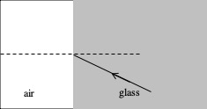
Demonstration 7: Based on your observations in Demonstrations 3 and 6, predict in which case on the right is it possible for there to be no transmitted ray (i.e., transmitted ray along the surface). Sketch this case on the diagram.  In this case, what percentage of the incident light is transmitted? What percentage of the incident light is reflected?  Only after you have made your predictions, open the same simulation as in the previous demonstrations. Set up the indexes of refraction to duplicate what you predicted. Adjust the angle of incidence of the laser beam and see if there is an angle of incidence for which there is no transmitted ray. If you can't find such an angle, reverse the indexes of refraction, and try again.  Once you have found an angle for which there is no transmitted ray, use the intensity meter to measure the transmitted and reflected intensities.  Compare your observations with your predictions and explain any differences. | 